*introduction*

**ABOUT PROJECT**

Passing out of school is a big time for most students because for most it is the first time they will have to make a life-changing choice, their undergraduate degree. This system aims to be a helpful and useful starting point for this confusing phase. There is a wealth of tools and data available for students who are interested in any field but most students do not have the time to research as well as required. This system will bring all these tools and data in one place for students.

In students life every step of career is very important. Most of student don’t think about their perfect path for successful career. They can’t understand or feel their passion, interest, hobby for choose perfect career for their life. Online career guidance test, this system helps you to know which career fit your personality.

This ‘Career Guidance Test’ web application can give them insight into their career personality. Based on a test of your personality in terms of you will learn what kind of your interest about work for their future career. The results of this career test provide you with a list of professions and occupations that fit your career personality. Choose a career that matches your preferences and you will increase your chances of being successful! This is useful for 10th and 12th students and also graduate students.

**ORGANIZATION PROFILE**

* **Organization name:** Online Career Guidance Test
* **Venue:** Gadhinglaj
* **Contact No.:** 9975702681 , 7721873482
* **Year of establishment:** 2019
* **Area of work:** Gadhinglaj
* **Owner(Partnership):** Mr. Akash Jotiba Ghatage .

Mr.Prathamesh Tanaji Savant.

*Manual System*

**EXISTING SYSTEM**

The existing system is based on old requirements of career choosing path. In this system consider marks or percentile of test for check best career path for students. This system use some question with their options and student have to choose one option as per his ability, interest or hobby. After complete this test then student show their marks or percentile and some options of career names which they have to choose. But this system is now outdated because this is wrong procedure to check someone’s passion or interest about their career. This is not a best way for a perfect guidance about career.

Some system shows four or six picture and gives option to student select their correct (✓) and wrong option (X) then show best career option according to this data. But this technique is not so much best because some time student confuse for select (✓) best way according to their interest. There are many systems are available but all are not successful to complete their main object. According to students this is good system but it is very expensive and confusable. Some time student get wrong information and they choose wrong path of career

**Limitations of Existing system**

* The existing system is based on old requirements of career choosing path.
* The existing system is not updated due to this many student have problems about choosing career.
* Less accuracy.
* They confuse about the result of tests, due to this student think about wrong career

path.

* system take lot of time and too many questions for checking their abilities.
* Fees of existing system is very expensive.
* The existing system is outdated and confusable.
* The existing system does not guide properly and not any perfect solution for a best career path.

.

**PROPOSED SYSTEM**

In the proposed system there are many new things are added for best result. It is updateable system for students for choose their best career path. This proposed system development develop for career guidance as well as improve communication skills. Career test that can helps students discover their passions and interests some of which they may not be aware of prior to taking the test. Once they have identified their passions and interests it will be easier to make more informed decisions regarding what career path they should choose. Career tests are designed to help the quiz takers gain insight into how they operate.

This information can help in determining the good traits as well as the bad traits you possess which in turn will help not just in your professional, but in your personal life as well. They may not be aware of what skills they possess that might attract the recruiters during campus placements. Taking skill developing tests will help you gain insights into this aspect of yours. Once you know what you are good at, it becomes easier to convince the recruiters of your worth. There are certain career tests website that are specifically designed for helping the quiz taker realize the values that hold the most importance to them. In other words, these tests help in defining what motivates students and what’s important to them.

**ADVANTAGES OF PROPOSED SYSTEM**

* All the information about test will be maintain properly in this system.
* Give perfect guidance of Passions and Interests
* Helpful for finding strengths and weaknesses about career.
* This system will provide a perfect report with explaination.
* Any difficulty of students can solve easily and quickly.
* It is very user friendly and easy to handle.
* Gives perfect results and advice that can satisfy all the needs of students.
* Save lot of time as well as money.
* Provides best procedure and easy way.
* Flexible and reliable for students on this site.

System analysis

**SYSTEM DEVELOPMENT LIFE CYCLE**

* **THE PROCESS MODEL USED FOR THE SYSTEM :**

The process model used for this system “Classic Life Cycle” as this is simple and is best for small scale project. The “Classic Life Cycle” is also called System Development Life Cycle (SDLC). It is defined “The growth of an information system is through various identifiable stages. These stages are grouped together and referred as SDLC.” The structure of its stages which we used in our project is as follows:

**Waterfall Model :**

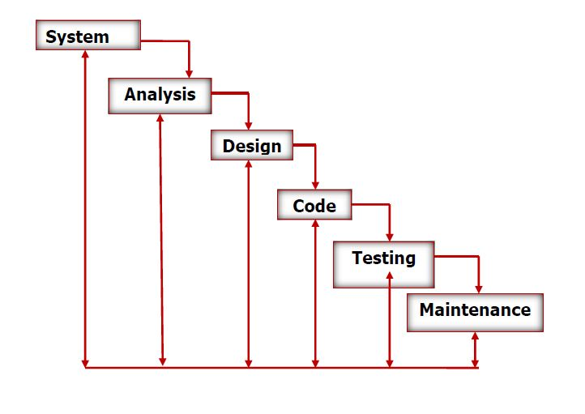

*(Dfd)*

*Data Flow diagram*

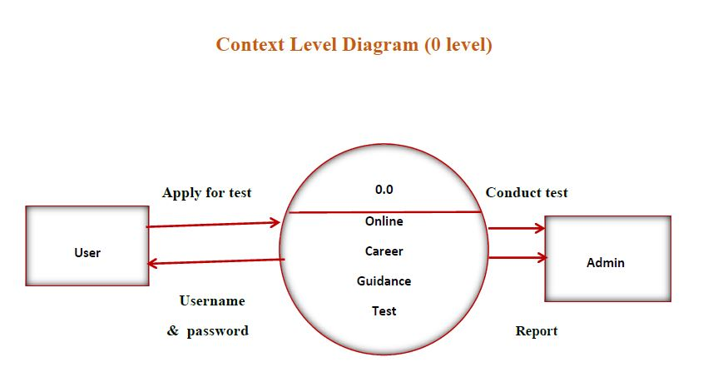

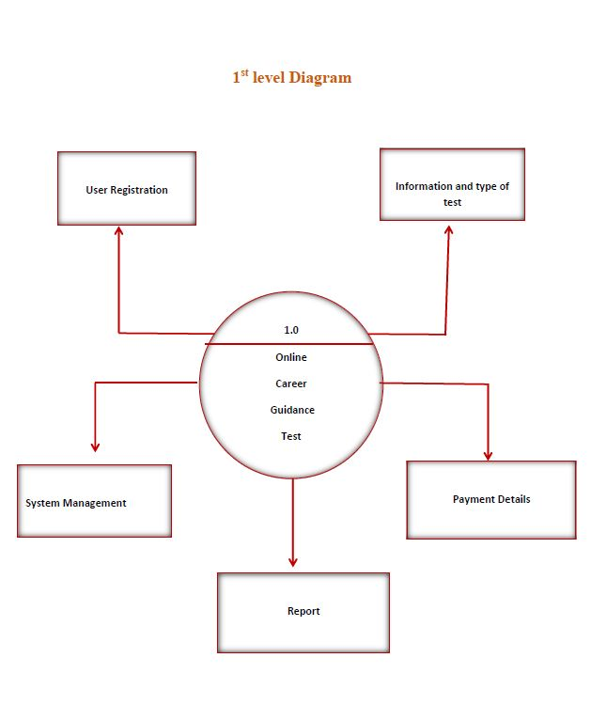

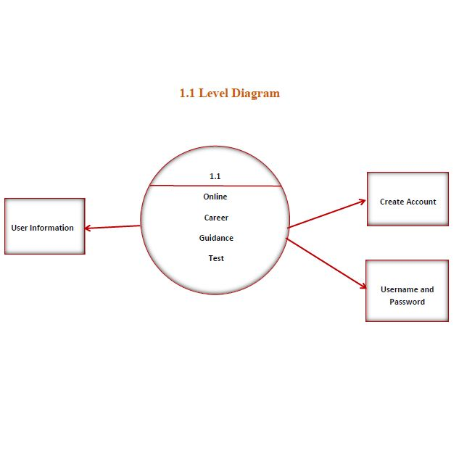

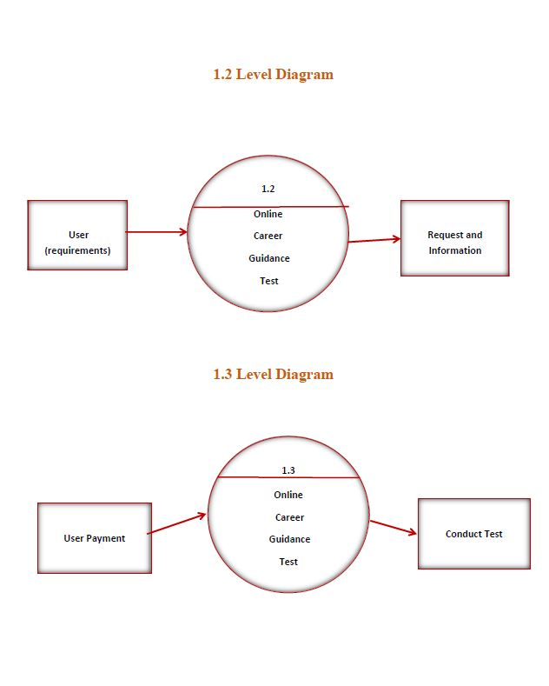

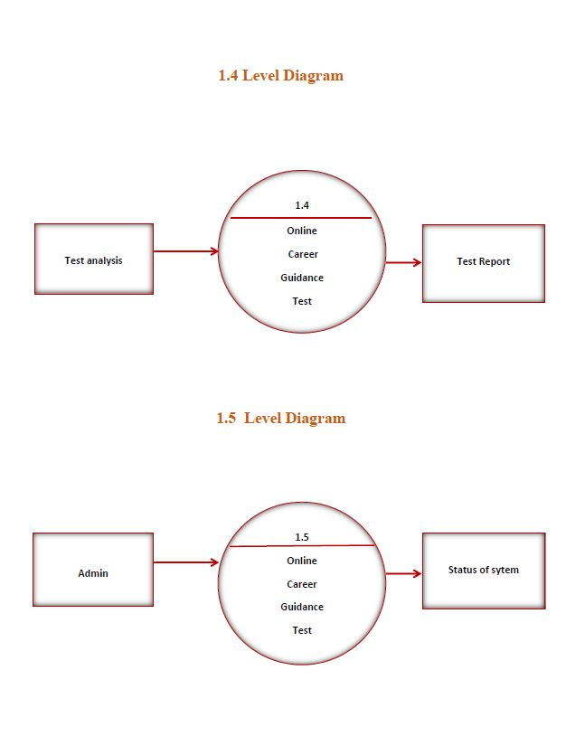

(erd)

Entity Relationship

Diagram

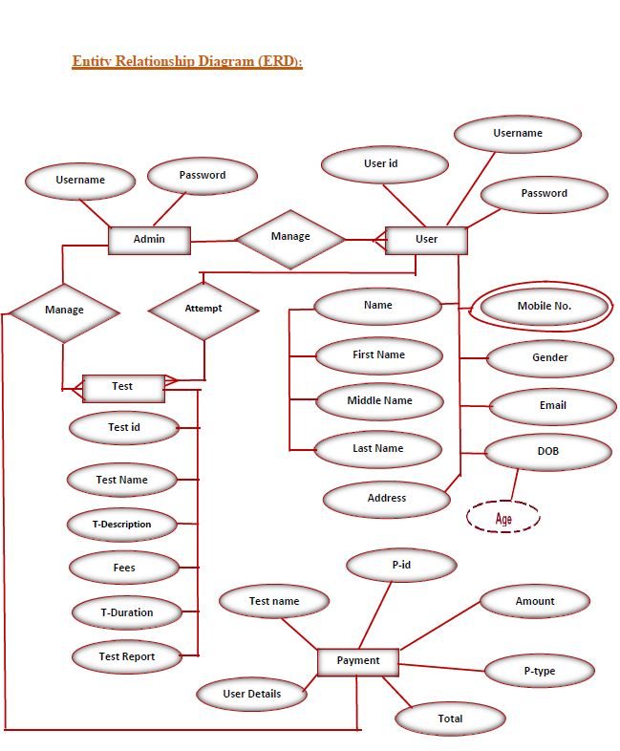

System

requirement

* **Software Requirement :**
* Net beans IDE 7.2
* SQL Server 2014
* Glassfish server 3.1
* Jasper Report 5.6
* Operating System:- Windows 7/8/10 64 bit.

* **Hardware Requirement :**
* Intel Dual Core or Higher Processor.
* 2 GB of RAM or Above.
* Minimum 20 GB Hard-Disk.
* 1 Keyboard and Mouse.
* Printer
* **Front End :**
* Advance Java
* JSP (HTML, CSS, Bootstrap)
* **Back End:**
* SQL Server
* **Reporting :**
* Jasper report

About java

**ABOUT JAVA**

Java is an object-oriented programming language developed by James Gosling and Colleagues at Sun Microsystem in early 1990s. Unlike conventional languages which are generally designed either to be compiled to native code, or to be interrupted from source code at runtime, Java is intended to be compiled to a byte code, which is then run (generally using JIT compilation) by a Java Virtual Machine.

Java was started as a project called “oak” by James Gosling in June 1991. Gosling goals were to implemented a virtual machine and a language that had a familiar C-like notation but with greater uniformly and simplicity then C and C++. The first public implementation was Java 1.0 in 1995. It made the promise of “Write Once, Run Anywhere”, with free runtimes on popular platforms. It was fairly secure and its security was configurable, allowing for network and access to be limited. The major web browsers soon incorporated it into their standard configuration in secure “Applet” configuration popular quickly. New versions for large and small platforms (J2EE and J2ME) soon were designed with the advent of “Java 2”. Sun has not announced any plans for a “Java 3”.

**ABOUT JAVA NET BEANS IDE 7.2**

The NetBeans Platform is a framework for simplifying the development of Java Swing desktop applications. The NetBeans IDE bundle for Java SE contains what is needed to start developing NetBeans plugins and NetBeans Platform based applications no additional JDK is required.

Applications can install modules dynamically. Any application can include the Update Centre module to allow users of the application to download digitally signed upgrades and new features directly into the running application. Reinstalling an upgrade or a new release does not force users to download the entire application again.

The platform offers reusable services common to desktop applications, allowing developers to focus on the logic specific to their application. Among the features of the platform are:

NetBeans IDE is an open-source integrated development environment. NetBeans IDE supports development of all Java application types (Java SE (including JavaFX), Java ME, web, EJB and mobile applications) out of the box. Among other features are an Ant-based project system, Maven support, refactoring, version control (supporting CVS, Subversion, Mercurial and Clear case).

**Modularity :**

All the functions of the IDE are provided by modules. Each module provides a well-defined function, such as support for the Java language, editing, or support for the CVS versioning system, and SVN. NetBeans contains all the modules needed for Java development in a single download, allowing the user to start working immediately. Modules also allow NetBeans to be extended. New features, such as support for other programming languages, can be added by installing additional modules. For instance, Sun Studio, Sun Java Studio Enterprise, and Sun Java Studio Creator from Sun Microsystems are all based on the NetBeans IDE.

**License :**

From July 2006 through 2007, NetBeans IDE was licensed under Sun's Common Development and Distribution License (CDDL), a license based on the Mozilla Public License (MPL). In October 2007, Sun announced that NetBeans would henceforth be offered under a dual license of the CDDL and the GPL version 2 licenses, with the GPL linking exception for GNU Class path

* User Interface Management (e.g. Menus and Toolbars)
* User Settings Management
* Storage Management (Saving and Loading any Kind of Data)
* Window Management
* Wizard Framework (Supports Step-by-Step Dialogs)
* NetBeans Visual Library
* Integrated Development Tools

About Sql

database

**WHAT IS DATABSASE**

A database is a separate application that stores a collection of data. Each database has one or more distinct Application for creating, accessing managing, searching and replicating the data it holds.

Other kinds of data stores can be used such as files on the file system or large hash tables in memory but data fetching and writing would not be fast and easy with those types of systems.

So now a day we use relational database management systems (RDBMS) to store and manage huge volume of data. This is called relational database because all the data is stored into different bales and relations are established using primary keys or other keys known as foreign keys.

**A RELATIONAL DATABASE MANAGEMENT SYSTEM (RDMS)**

* Enables you to implement a database with tables, columns and indexes.
* Guarantees the Referential Integrity betweenrows of varioustables.
* Updates the indexes automatically.
* Interprets a SQL query and combines information from various tables.

**SQL DATABASE**

# SQL Server Management Studio :

SQL is a fast, easy-to-use RDBMS being used for many small and big businesses. SQL was initially developed at IBM by DONALD Chamberlin and Raymond Boyce after learning about the relation model from Ted Cod in the early 1970 s.:

* SQL is released under an open-source license. So you have nothing to pay to use it.
* SQL is a very powerful program in its own right. It handles a large subset of the functionality of the most expensive and powerful database packages.
* SQL uses a standard form of the well-known SQL data language.
* SQL works on many operating systems and with many languages including PHP, PERL, C, C++, JAVA, etc.
* SQL works very quickly and works well even with large data sets.
* SQL is very friendly to all language, the most appreciated language for web development.
* SQL supports large databases, up to 50 million rows or more in a table. The default file size limit for a table is 4GB, but you can increase this (if your operating system can handle it) to a theoretical limit of 8 million terabytes (TB).

Database

design

**User Registration :**

|  |  |  |
| --- | --- | --- |
| Column Name | Data Type | Description |
| U_id | int | It store user id |
| F_name | nvarchar(200) | It store First name |
| M_name | nvarchar(200) | It store Middle name |
| L_name | numeric(200) | It srore Last name |
| Address | nchar(250) | It store Address |
| Age | nvarchar(50) | It store Age |
| DOB | date | It store dateof birth |
| C_Number | numeric(12,0) | It store Contact Number |
| Email_ID | nvarchar(200) | It store email id |
| User_Name | Nvarchar(250) | It store User name |
| Password | nvarchar(200) | It store Password |
| C_Password | nvarchar(200) | It store Confirm Password |
| Photo | nvarchar(200) | It store Photo |
| Sign_Photo | nvarchar(200) | It store Signature photo |
| Date | date | It store registration date |

**Payment :**

|  |  |  |
| --- | --- | --- |
| Column Name | Data Type | Description |
| P_id | int | It store payment id |
| P_Type | nvarchar(50) | it store accessory type |
| Bank_Name | nvarchar(50) | it store product id |
| SixteenDNumber | numeric(16,0) | it store company name |
| ThreeDNumber | numeric(3,0) | it store manufacture date |
| User_Name | nvarchar(50) | it store description of accessories |
| Date | date | it store feature of accessories |

**Feedback:**

|  |  |  |
| --- | --- | --- |
| Column name | Data Type | Description |
| F_id | Int | it store bill no |
| Name | nvarchar(50) | it store customer name |
| Issues | nvarchar(50) | it store model name |
| Date | Int | it store product rate |

**Add Question:**

|  |  |  |
| --- | --- | --- |
| Column Name | Data Type | Description |
| AQ_id | int | it store Add question id |
| Exam_ID | numeric(18,0) | it store exam id |
| Q_Number | numeric(18,0) | it store question number |
| Question | nvarchar(1500) | it store question |
| O_A | nvarchar(500) | it store option A |
| O_B | nvarchar(500) | it store option B |
| O_C | nvarchar(500) | it store option C |
| O_D | nvarchar(500) | it store option D |
| C_O | nvarchar(500) | it store correct option |
| E_Type | nvarchar(50) | it store exam type |
| Date | date | It store date of exam |

**Time master:**

|  |  |  |
| --- | --- | --- |
| Column Name | Data Type | Description |
| T_id | int | it store time id |
| Time | nvarchar(50) | it store time |

**Student Question Sheet:**

|  |  |  |
| --- | --- | --- |
| Column Name | Data Type | Description |
| T_id | int | it store test id |
| Q_Number | Numeric(18,0) | it store question number |
| Question | nvarchar(500) | it store question |
| Option_A | nvarchar(150) | it store option A |
| Option_B | nvarchar(150) | it store option B |
| Option_C | nvarchar(150) | it store option C |
| Option_D | nvarchar(150) | it store option D |

Source

Code

* **Admin Side Home JSP Page**

<%--

Document : A_HomePage

Created on : Feb 5, 2020, 9:28:52 AM

Author : admin

--%>

<%@page contentType="text/html" pageEncoding="UTF-8"%>

<!DOCTYPE html>

<html>

<head>

<meta http-equiv="Content-Type" content="text/html; charset=UTF-8">

<title>A_HomePage</title>

<style>

body{

margin:0;

margin:0;

background:url(homepage.jpg);

background-repeat: no-repeat;

background-size: cover;

}

h3{

font-family: Algerian;

color:skyblue;

margin:0%;

padding:0%;

font-size: 50px;

margin-bottom: 50px;

padding: 3px;

}

h2{

font-family: Algerian;

color:orange;

margin:0%;

padding:0%;

font-size: 40px;

}

.home{

position: static;

top:50%;

left:50%;

color:black;

}

.navbar{

top:20%;

width:100%;

background:#6699cc;

box-shadow: 0 2px 5px 0 rgba(0,0,0,0.16), 0 2px 10px 0 rgba(0,0,0,0.12);

}

ul{

text-align: left;

display: inline;

margin: 0;

padding: 0;

list-style: none;

}

ul li{

font: bold 12px sans-serif;

display: inline-block;

position: relative;

padding: 15px 30px;

background: #6699cc;

}

ul li a{

text-decoration: none;

padding: 25px 20px;

color: white;

font-size: 20px;

}

ul li:hover{

background: #4dd0e1;

color:white;

}

</style>

</head>

<body>

<br><br>

<h3><marquee>CAREER GUIDANCE TEST</marquee></h3>

<div class="navbar">

<ul>

<li><a href="Admin_pannel.jsp">Admin Panel</a></li>

<li><a href="Time_Master.jsp">Add Exam</a></li>

<li><a href="Report.jsp">Report</a></li>

<li><a href="About.jsp">About Us</a></li>

<li><a href="Contact Us.jsp">Contact Us</a></li>

<li><a href="second.jsp">LogOut</a></li>

</ul>

</div>

<br>

<h2>

&nbsp; &nbsp; Choose Your Perfect Career Way For Your Great Success....

</h2>

<img src="career-banner.jpg" style="top:70%;left:10%;width:100%; height: 570px;">

</body>

</html>

* **Add Question JSP Page**

<%--

Document : Add_Question

Created on : Dec 26, 2019, 11:13:49 PM

Author : admin

--%>

<%@page contentType="text/html" pageEncoding="UTF-8"%>

<!DOCTYPE html>

<html>

<head>

<meta http-equiv="Content-Type" content="text/html; charset=UTF-8">

<title>Add Question</title>

<link rel="Stylesheet" href="bootstrap.css">

<script>

function clear()

{

document.getElementById("ei").value="1";

document.getElementById("qn").value="";

document.getElementById("q").value="";

document.getElementById("op1").value="";

document.getElementById("op2").value="";

document.getElementById("op3").value="";

document.getElementById("op4").value="";

document.getElementById("co").value="";

}

</script>

<style>

*{

margin: 0;

padding: 0;

}

body{

background-image: url("Save.jpg");

background-size: cover;

}

.jambotron{

background-color: white;

margin-left:300px;

margin-right:300px;

opacity: 0.9;

border: 3px solid black;

border-radius: 30px;

}

h2{

text-shadow: 2px 2px 2px blue;

}

button{

height: 40px;

transition-property: height;

transition-duration: 0.3s;

transition-timing-function: linear;

}

button:hover{

text-align: center;

height:50px;

}

</style>

</head>

<body>

<form action="Add_Question" name="Add_Question" method="post">

<script src="validation.js"></script>

<br><br><br>

<div class="jambotron">

<h2><center>Add Question</center></h2><br><br>

<div class="row">

<div class="col-sm-2"></div>

<div class="col-sm-4">

<label>Exam Id-:</label>

</div>

<div class="col-sm-4">

<input type="text" id="ei" name="Exam_Id" value="<%=request.getAttribute("E_type")%>" class="form-control">

</div>

</div><br><br>

<div class="row">

<div class="col-sm-2"></div>

<div class="col-sm-4">

<label>Question Number-:</label>

</div>

<div class="col-sm-4">

<input type="text" class="form-control" id="qn" value="<%=request.getAttribute("Q_no")%>" name="Q_Number" onkeypress="javascript:return isNumber(event)">

</div>

</div><br><br>

<div class="row">

<div class="col-sm-2"></div>

<div class="col-sm-4">

<label>Question -:</label>

</div>

</div><br>

<div class="row">

<div class="col-sm-1"></div>

<div class="col-sm-10">

<textarea row="3" col="10" id="q" name="Question" class="form-control"><%=request.getAttribute("Ques")%></textarea>

</div>

</div><br><br>

<div class="row">

<div class="col-sm-3"></div>

<div class="col-sm-1"><label>A)</label></div>

<div class="col-sm-4"><input type="text" id="op1" value="<%=request.getAttribute("oa")%>" name="Option_A"class="form-control"></div>

</div><br><br>

<div class="row">

<div class="col-sm-3"></div>

<div class="col-sm-1"><label>B)</label></div>

<div class="col-sm-4"><input type="text" id="op2" value="<%=request.getAttribute("ob")%>" name="Option_B" class="form-control"></div>

</div><br><br>

<div class="row">

<div class="col-sm-3"></div>

<div class="col-sm-1"><label>C)</label></div>

<div class="col-sm-4"><input type="text" id="op3" value="<%=request.getAttribute("oc")%>" name="Option_C" class="form-control"></div>

</div><br><br>

<div class="row">

<div class="col-sm-3"></div>

<div class="col-sm-1"><label>D)</label></div>

<div class="col-sm-4"><input type="text" id="op4" value="<%=request.getAttribute("od")%>" name="Option_D" class="form-control"></div>

</div><br><br>

<div class="row">

<div class="col-sm-2"></div>

<div class="col-sm-2"><label>Correct</label></div>

<div class="col-sm-4"><input type="text" id="co" value="<%=request.getAttribute("co")%>" name="Option_Corect" class="form-control"></div>

</div><br><br>

<div class="row">

<div class="col-sm-1"></div>

<div class="col-sm-2">

<button input="submit" name="btn_submit" value="Save" class="btn btn-success" style="width:80px;">Save</button>

</div>

<div class="col-sm-2">

<button input="submit" name="btn_submit" value="Update" class="btn btn-primary" style="width:80px;">Update</button>

</div>

<div class="col-sm-2">

<button input="submit" name="btn_submit" value="Delete" class="btn btn-danger" style="width:80px;">Delete</button>

</div>

<div class="col-sm-2">

<button input="submit" name="btn_submit" value="Search" class="btn btn-primary" style="width:80px;">Search</button>

</div>

<div class="col-sm-2">

<button input="submit" name="btn_submit" value="Exit" class="btn btn-danger" style="width:80px;">Exit</button>

</div><br><br><br>

</div>

</div>

<%

if(request.getAttribute("Ques")==null)

{

%>

<script>

clear();

</script>

<%

}

%>

</form>

</body>

</html>

* **Add Question Servlet Page**

import java.io.IOException;

import java.io.PrintWriter;

import java.net.ConnectException;

import java.sql.Connection;

import java.sql.DriverManager;

import java.sql.ResultSet;

import java.sql.Statement;

import java.text.SimpleDateFormat;

import java.util.Date;

import javax.servlet.ServletException;

import javax.servlet.annotation.WebServlet;

import javax.servlet.http.HttpServlet;

import javax.servlet.http.HttpServletRequest;

import javax.servlet.http.HttpServletResponse;

import javax.servlet.http.HttpSession;

import javax.websocket.Session;

/**

*

* @author admin

*/

@WebServlet(name = "Add_Question", urlPatterns = {"/Add_Question"})

public class Add_Question extends HttpServlet {

Connection cn = null;

Statement st = null;

@Override

protected void doPost(HttpServletRequest req, HttpServletResponse resp) throws ServletException, IOException {

PrintWriter out = resp.getWriter();

String ExamId = req.getParameter("Exam_Id");

String Qusetion_Number = req.getParameter("Q_Number");

String Question = req.getParameter("Question");

String Option_A = req.getParameter("Option_A");

String Option_B = req.getParameter("Option_B");

String Option_C = req.getParameter("Option_C");

String Option_D = req.getParameter("Option_D");

String Option_Correct = req.getParameter("Option_Corect");

String event = req.getParameter("btn_submit");

out.println(ExamId);

out.println(Qusetion_Number);

out.println(Question);

out.println(Option_A);

out.println(Option_B);

out.println(Option_C);

out.println(Option_D);

out.println(Option_Correct);

Database db = new Database();

String result = db.Connectdb();

out.println(result);

HttpSession session=req.getSession();

if(event.equals("Exit"))

{

resp.sendRedirect("A_HomePage.jsp");

}

if (event.equals("Save"))

{

Date date=new Date();

SimpleDateFormat dates=new SimpleDateFormat("yyyy-MM-dd");

String date1=dates.format(date);

String insert = db.Insert("insert into Add_Question(Exam_Id,Q_Number,Question,O_A,O_B,O_C,O_D,C_O,E_type,date)values('"+ExamId.toString()+"','"+Qusetion_Number.toString()+"','"+Question.toString()+"','"+Option_A.toString()+"','"+Option_B.toString()+"','"+Option_C.toString()+"','"+Option_D.toString()+"','"+Option_Correct.toString()+"','"+session.getAttribute("etype")+"','"+date.toString()+"')");

out.println(insert);

resp.setContentType("text/html;charset=UTF-8");

out.println("<script type=\"text/javascript\">");

out.println("alert('Question Add Successfully');");

out.println("location='Add_Question.jsp';");

out.println("</script>");

}

if (event.equals("Update")) {

try {

String update = db.Update("update Add_Question set Exam_Id='" + ExamId.toString() + "',Question='" + Question.toString() + "',O_A='" + Option_A.toString() + "',O_B='" + Option_B.toString() + "',O_C='" + Option_C.toString() + "',O_D='" + Option_D.toString() + "',C_O='" + Option_Correct.toString() + "' where Q_Number='" + Qusetion_Number.toString() + "'");

out.println(update);

resp.setContentType("text/html;charset=UTF-8");

out.println("<script type=\"text/javascript\">");

out.println("alert('Record Updated');");

out.println("location='Add_Question.jsp';");

out.println("</script>");

} catch (Exception ex) {

out.println(ex.toString());

}

}

if (event.equals("Delete")) {

try {

String delete = db.Delete("delete from Add_Question where Q_Number='" + Qusetion_Number.toString() + "' ");

out.println(delete);

resp.setContentType("text/html;charset=UTF-8");

out.println("<script type=\"text/javascript\">");

out.println("alert('Record Deleted');");

out.println("location='Add_Question.jsp';");

out.println("</script>");

} catch (Exception ex) {

out.println(ex.toString());

}

}

if (event.equals("Search")) {

Connection cn = null;

Statement st = null;

try {

Class.forName("sun.jdbc.odbc.JdbcOdbcDriver");

cn = DriverManager.getConnection("jdbc:odbc:IQ_TEST");

st = cn.createStatement();

String sql = "select * from Add_Question where Q_Number='" + Qusetion_Number.toString() + "'";

ResultSet rs = st.executeQuery(sql);

while (rs.next()) {

req.setAttribute("E_type", rs.getString("Exam_Id"));

req.setAttribute("Q_no", rs.getString("Q_Number"));

req.setAttribute("Ques", rs.getString("Question"));

req.setAttribute("oa", rs.getString("O_A"));

req.setAttribute("ob", rs.getString("O_B"));

req.setAttribute("oc", rs.getString("O_C"));

req.setAttribute("od", rs.getString("O_D"));

req.setAttribute("co", rs.getString("C_O"));

req.getRequestDispatcher("Add_Question.jsp").forward(req, resp);

}

/* resp.setContentType("text/html;charset=UTF-8");

out.println("<script type=\"text/javascript\">");

out.println("alert('Record Selected');");

out.println("location='Add_Question.jsp';");

out.println("</script>");*/

} catch (Exception ex) {

out.println(ex.toString());

}

}

}

}

* **User Registration JSP Page**

<%--

Document : User_Registration

Created on : Dec 4, 2019, 10:39:33 PM

Author : admin

--%>

<%@page contentType="text/html" pageEncoding="UTF-8"%>

<!DOCTYPE html>

<html>

<head>

<meta http-equiv="Content-Type" content="text/html; charset=UTF-8">

<title>User_Registration</title>

<link rel="Stylesheet" href="bootstrap.css">

<style>

*{

margin: 0;

padding:0;

}

.jambotron{

background-color: white;

margin-left:320px;

margin-right:240px;

opacity: 0.9;

border: 3px solid black;

border-radius: 30px;

}

h1{

text-shadow: 2px 2px 2px blue;

}

body{

background-image: url("Save.jpg");

background-size: cover;

}

button{

width:100px;height: 40px;

transition-property: width,height;

transition-duration: 0.5s;

transition-timing-function: linear;

}

button:hover{

text-align: center;

width:120px;height: 50px;

}

</style>

</head>

<body>

<script src="validation.js"></script>

<form action="User_Registration" name="User_Registration" method="post">

<br>

<div class="jambotron"><br>

<center><h1><b>Registration</b></h1></center><br><br>

<div class="row">

<div class="col-sm-2"></div>

<div class="col-sm-3">

<label>First Name</label>

</div>

<div class="col-sm-3">

<label>Middle Name</label>

</div>

<div class="col-sm-3">

<label>Last Name</label>

</div>

</div>

<div class="row">

<div class="col-sm-2"></div>

<div class="col-sm-3">

<input type="text" name="txt_Fname" class="form-control" onkeypress="javascript:return isString(event)" required="">

</div>

<div class="col-sm-3">

<input type="text" name="txt_Mname" class="form-control" onkeypress="javascript:return isString(event)" required="">

</div>

<div class="col-sm-3">

<input type="text" name="txt_Lname" class="form-control" onkeypress="javascript:return isString(event)" required="">

</div>

</div><br>

<div class="row">

<div class ="col-sm-3"></div>

<div class="col-sm-3">

<label>Address :- </label>

</div>

<div class="col-sm-4">

<textarea rows="3" cols="20"class="form-control" name="txt_add" required=""></textarea><br>

</div>

</div>

<div class="row">

<div class ="col-sm-3"></div>

<div class="col-sm-3">

<label>Age:- </label>

</div>

<div class="col-sm-4">

<input type="text" class="form-control" maxlength="2" name="txt_Age" onkeypress="javascript:return isNumber(event)" required=""><br>

</div>

</div>

<div class="row">

<div class ="col-sm-3"></div>

<div class="col-sm-3">

<label>Gender:- </label>

</div>

<div class="row">

<div class="col-sm-4">

<input type="radio" name="gender" value="Male">Male

<input type="radio" name="gender" value="Female">Female<br><br>

</div>

</div>

<div class="row">

<div class ="col-sm-3"></div>

<div class="col-sm-3">

<label>DOB:- </label>

</div>

<div class="col-sm-4">

<input type="date" name="dob" class="form-control" required=""><br>

</div>

</div>

<div class="row">

<div class ="col-sm-3"></div>

<div class="col-sm-3">

<label>Contact Number:- </label>

</div>

<div class="col-sm-4">

<input type="text" name="txt_cono" maxlength="10" class="form-control" onkeypress="javascript:return isNumber(event)" required=""><br>

</div>

</div>

<div class="row">

<div class ="col-sm-3"></div>

<div class="col-sm-3">

<label>Email Id:- </label>

</div>

<div class="col-sm-4">

<input type="email" name="email" class="form-control" required=""><br><br>

</div>

</div>

<div class="row">

<div class ="col-sm-3"></div>

<div class="col-sm-3">

<label>User Name:- </label>

</div>

<div class="col-sm-4">

<input type="text" name="U_Name" class="form-control" required=""><br>

</div>

</div>

<div class="row">

<div class ="col-sm-3"></div>

<div class="col-sm-3">

<label>password:- </label>

</div>

<div class="col-sm-4">

<input type="password" name="Password" id="password" class="form-control" onkeyup='check();' maxlength="15" required=""><br>

</div>

</div>

<div class="row">

<div class ="col-sm-3"></div>

<div class="col-sm-3">

<label>Confirm Password:- </label>

</div>

<div class="col-sm-4">

<input type="password" name="C_Password" class="form-control" id="confirm_password" onkeyup='check();' maxlength="15" required=""><br>

<span id='message'></span>

</div>

</div>

<div class="row">

<div class ="col-sm-3"></div>

<div class="col-sm-3">

<label>Upload Photo:- </label>

</div>

<div class="col-sm-4">

<input type="File" name="Photo" required=""><br>

<span id='message'></span>

</div>

</div>

<div class="row">

<div class ="col-sm-3"></div>

<div class="col-sm-3">

<label>Upload Sign:- </label>

</div>

<div class="col-sm-4">

<input type="File" name="SPhoto" required=""><br>

<span id='message'></span>

</div>

</div>

<br>

<br>

<div class="row">

<div class ="col-sm-4"></div>

<div class="col-sm-2">

<a href="Login.jsp" class="btn btn-danger" style="height: 40px; width: 90px;">Cancel</a>&nbsp;&nbsp;&nbsp;

</div>

<div class="col-sm-2">

<input type="submit" name="btnn" class="btn btn-success" value="Registration" style="height: 40px;">

</div>

<br>

<br>

<br>

<br>

</div>

</div>

</div>

<br>

<br>

<script type="text/javascript">

var check = function() {

if (document.getElementById('password').value ==

document.getElementById('confirm_password').value) {

document.getElementById('message').style.color = 'green';

document.getElementById('message').innerHTML = 'matching';

} else {

document.getElementById('message').style.color = 'red';

document.getElementById('message').innerHTML = 'not matching';

}

}

</script>

</form>

</body>

</html>

* **User Registration Servlet Page**

/*

* To change this template, choose Tools | Templates

* and open the template in the editor.

*/

import java.io.IOException;

import java.io.PrintWriter;

import java.sql.Connection;

import java.sql.DriverManager;

import java.sql.Statement;

import java.text.SimpleDateFormat;

import java.util.Date;

import javax.servlet.ServletException;

import javax.servlet.annotation.WebServlet;

import javax.servlet.http.HttpServlet;

import javax.servlet.http.HttpServletRequest;

import javax.servlet.http.HttpServletResponse;

/**

*

* @author admin

*/

@WebServlet(name = "User_Registration", urlPatterns = {"/User_Registration"})

public class User_Registration extends HttpServlet {

@Override

protected void doPost(HttpServletRequest req, HttpServletResponse resp) throws ServletException, IOException {

PrintWriter out=resp.getWriter();

String First_Name=req.getParameter("txt_Fname");

String Middle_Name=req.getParameter("txt_Mname");

String Last_Name=req.getParameter("txt_Lname");

String Address=req.getParameter("txt_add");

String Age=req.getParameter("txt_Age");

String Gender=req.getParameter("gender");

String DOB=req.getParameter("dob");

String Contact_Number=req.getParameter("txt_cono");

String Email_Id=req.getParameter("email");

String User_Name=req.getParameter("U_Name");

String Password=req.getParameter("Password");

String C_Password=req.getParameter("C_Password");

String Photo=req.getParameter("Photo");

String SPhoto=req.getParameter("SPhoto");

String event=req.getParameter("btnn");

out.println(First_Name);

out.println(Middle_Name);

out.println(Last_Name);

out.println(Address);

out.println(Age);

out.println(Gender);

out.println(DOB);

out.println(Contact_Number);

out.println(Email_Id);

out.println(User_Name);

out.println(Password);

out.println(C_Password);

out.println(Photo);

out.println(SPhoto);

Database db=new Database();

String result=db.Connectdb();

out.println(result);

if(event.equals("Registration"))

{

try

{

Date d=new Date();

SimpleDateFormat dates=new SimpleDateFormat("yyyy-MM-dd");

String date1=dates.format(d);

String insert=db.Insert("insert into User_Registration(F_Name,M_Name,L_Name,Address,Age,Gender,DOB,C_Number,Email_ID,User_Name,Password,C_Password,Photo,sphoto,date)values('"+First_Name.toString()+"','"+Middle_Name.toString()+"','"+Last_Name.toString()+"','"+Address.toString()+"','"+Age.toString()+"','"+Gender.toString()+"','"+DOB.toString()+"','"+Contact_Number.toString()+"','

"+Email_Id.toString()+"','"+User_Name.toString()+"','"+Password.toString()+"','"+C_Password.toString()+"','Profilepics/"+Photo.toString()+"','Sign/"+SPhoto.toString()+"','"+date1.toString()+"')");

out.println(insert);

resp.setContentType("text/html;charset=UTF-8");

out.println("<script type=\"text/javascript\">");

out.println("alert('Registration Successfully');");

out.println("location='Payment.jsp';");

out.println("</script>");

}

catch(Exception ex)

{

out.println(ex.toString());

}

}

if(event.equals("Cancel"))

{

resp.sendRedirect("Login.jsp");

}

}

}

* **Student Question Sheet JSP Page**

<%--

Document : Student_Question_Sheet

Created on : Dec 31, 2019, 9:16:44 AM

Author : admin

--%>

<%@page import="java.sql.ResultSet"%>

<%@page import="java.sql.DriverManager"%>

<%@page import="java.sql.Statement"%>

<%@page import="java.sql.Connection"%>

<%@page contentType="text/html" pageEncoding="UTF-8"%>

<!DOCTYPE html>

<html>

<head>

<meta http-equiv="Content-Type" content="text/html; charset=UTF-8">

<title>Student Question Sheet</title>

<link rel="Stylesheet" href="bootstrap.css">

<style>

*{

margin: 0;

padding: 0;

}

body{

background-image: url("Save.jpg");

background-size: cover;

}

.jambotron{

background-color: white;

margin-left:350px;

margin-right:350px;

opacity: 0.9;

border: 3px solid black;

border-radius: 30px;

}

h2{

text-shadow: 2px 2px 2px blue;

}

button{

top:30px;

height: 40px;

transition-property: height;

transition-duration: 0.3s;

transition-timing-function: linear;

}

button:hover{

text-align: center;

height:50px;

}

</style>

</head>

<body>

<%

Connection cn=null;

Statement st=null;

String qno="";

String qustion="";

String op1="";

String op2="";

String op3="";

String op4="";

String ans="";

try

{

Class.forName("sun.jdbc.odbc.JdbcOdbcDriver");

cn=DriverManager.getConnection("jdbc:odbc:IQ_TEST");

st=cn.createStatement();

String sql="select * from Add_Question where Q_Number='"+session.getAttribute("qno") +"' and E_type='"+session.getAttribute("etype") +"'";

ResultSet rs=st.executeQuery(sql);

while(rs.next())

{

qno=rs.getString("Q_Number");

qustion=rs.getString("Question");

op1=rs.getString("O_A");

op2=rs.getString("O_B");

op3=rs.getString("O_C");

op4=rs.getString("O_D");

ans=rs.getString("C_O");

}

}catch(Exception ex)

{

out.println(ex.toString());

}

%>

<form action="Student_Q_Sheet" method="post" name="Student_Q_Sheet">

<script>

</script>

<br>

<div class="row">

<div class="col-sm-1"></div>

<div class="col-sm-2">

<h4>Test Type-:</h4>

</div>

<div class="col-sm-2">

<input type="text" name="etype" class="form-control" value="<%=session.getAttribute("etype")%>" readonly>

</div>

<div class="col-sm-3"></div>

<div class="col-sm-2">

<h4>Time</h4>

</div>

<div class="col-sm-2">

<input type="hidden" value="<%=session.getAttribute("time")%>" id="time">

<center><h4 style="margin-top:0px">Time Left</h4></center><p id="demo" style="" ></p>

<img style="margin-left: 50px;margin-top: 10px" src="<%=session.getAttribute("photo")%>" width="100" height="100">

<script>

// Set the date we're counting down to

var time=document.getElementById("time").value;

var countDownDate = new Date(time).getTime();

//Mar, 5 2019 16:30:00

// Update the count down every 1 second

var x = setInterval(function() {

// Get todays date and time

var now = new Date().getTime();

// Find the distance between now and the count down date

var distance = countDownDate - now;

// Time calculations for days, hours, minutes and seconds

var hours = Math.floor((distance % (1000 * 60 * 60 * 24)) / (1000 * 60 * 60));

var minutes = Math.floor((distance % (1000 * 60 * 60)) / (1000 * 60));

var seconds = Math.floor((distance % (1000 * 60)) / 1000);

// Output the result in an element with id="demo"

document.getElementById("demo").innerHTML =hours +"h "

+ minutes + "m " + seconds + "s ";

// If the count down is over, write some text

if (distance < 0) {

clearInterval(x);

document.getElementById("demo").innerHTML = "Exam Is Over";

}

}, 1000);

</script>

</div>

</div><br>

<div class="jambotron" style="margin-top: -100px">

<h2><center>Test</center></h2><br><br>

<div class="row">

<div class="col-sm-1"></div>

<div class="col-sm-2"><label>Q.Number-:</label></div>

<div class="col-sm-1">

<input type="text" name="Q_Number" value="<%=session.getAttribute("qno")%>" onkeypress="javascript:return isNumber(event)" readonly="" >

</div>

</div><br>

<div class="row">

<div class="col-sm-1"></div>

<div class="col-sm-2"><label>Question -:</label></div>

<div class="col-sm-4">

</div>

</div><br>

<div class="row">

<div class="col-sm-1"></div>

<div class="col-sm-9">

<textarea row="3" col="10" name="Question" class="form-control"><%=qustion%></textarea>

</div>

</div><br><br>

<div class="row">

<div class="col-sm-2"></div>

<div class="col-sm-1">A)</div>

<div class="col-sm-3"><input type="radio" name="option1" value="<%=op1%>"><%=op1%></div>

</div><br><br>

<div class="row">

<div class="col-sm-2"></div>

<div class="col-sm-1">B)</div>

<div class="col-sm-2"><input type="radio" name="option1" value="<%=op2%>"><%=op2%></div>

</div><br><br>

<div class="row">

<div class="col-sm-2"></div>

<div class="col-sm-1">C)</div>

<div class="col-sm-2"><input type="radio" name="option1" value="<%=op3%>"><%=op3%></div>

</div><br><br>

<div class="row">

<div class="col-sm-2"></div>

<div class="col-sm-1">D)</div>

<div class="col-sm-2"><input type="radio" name="option1" value="<%=op4%>"><%=op4%></div>

<input type="hidden" name="ans" value="<%=ans%>">

</div><br><br>

<div class="row">

<div class="col-sm-1"></div>

<div class="col-sm-2">

</div>

<div class="col-sm-2">

<input type="submit" name="btn_submit" value="Previous" class="btn btn-primary" style="width:80px;">

</div>

<div class="col-sm-2">

<input type="submit" name="btn_submit" value="Next" class="btn btn-primary" style="width:80px;">

</div>

<div class="col-sm-2">

<input type="submit" value="Submit" name="btn_submit" class="btn btn-success" style="width:70px;">

</div>

</div><br><br>

</div>

</form>

</body>

</html>

* **Student Question Sheet Servlet Page**

/*

* To change this template, choose Tools | Templates

* and open the template in the editor.

*/

import java.io.IOException;

import java.io.PrintWriter;

import javax.servlet.ServletException;

import javax.servlet.annotation.WebServlet;

import javax.servlet.http.HttpServlet;

import javax.servlet.http.HttpServletRequest;

import javax.servlet.http.HttpServletResponse;

import javax.servlet.http.HttpSession;

/**

*

* @author admin

*/

@WebServlet(name = "Student_Q_Sheet", urlPatterns = {"/Student_Q_Sheet"})

public class Student_Q_Sheet extends HttpServlet {

protected void doPost(HttpServletRequest req, HttpServletResponse resp) throws ServletException, IOException {

PrintWriter out=resp.getWriter();

String Qusetion_Number=req.getParameter("Q_Number");

String Question=req.getParameter("Question");

String radio=req.getParameter("option1");

String etype=req.getParameter("etype");

String cans=req.getParameter("ans");

String event=req.getParameter("btn_submit");

out.println(Qusetion_Number);

out.println(Question);

out.println(radio);

out.println(cans);

HttpSession session=req.getSession();

Database db=new Database();

String result=db.Connectdb();

out.println(result);

if(radio!=null)

{

if(event.equals("Next"))

{

try

{

int marks;

if(radio.equals(cans))

{

marks=1;

}else

{

marks=0;

}

String insert=db.Insert("insert into student_result(Q_No,Question,Selected_Option,C_Ans,Marks,User_Name,Password,Exam_Type)values('"+Qusetion_Number.toString()+"','"+Question.toString()+"','"+radio.toString()+"','"+cans.toString()+"','"+marks+"','"+session.getAttribute("username") +"','"+session.getAttribute("password") +"','"+etype.toString()+"')");

out.println(insert);

int qno=Integer.parseInt(session.getAttribute("qno").toString())+1;

session.setAttribute("qno", qno);

resp.sendRedirect("Student_Question_Sheet.jsp");

}

catch(Exception ex)

{

out.println(ex.toString());

}

}

if(event.equals("Previous"))

{

int qno=Integer.parseInt(session.getAttribute("qno").toString())-1;

session.setAttribute("qno", qno);

resp.sendRedirect("Student_Question_Sheet.jsp");

}

if(event.equals("Submit"))

{

resp.sendRedirect("Result.jsp");

}

}

else

{

resp.setContentType("text/html;charset=UTF-8");

out.println("<script type=\"text/javascript\">");

out.println("alert('Please Select Option');");

out.println("location='Student_Question_Sheet.jsp';");

out.println("</script>");

}

}

}

*Output*

*design*

* **Admin Registration:**

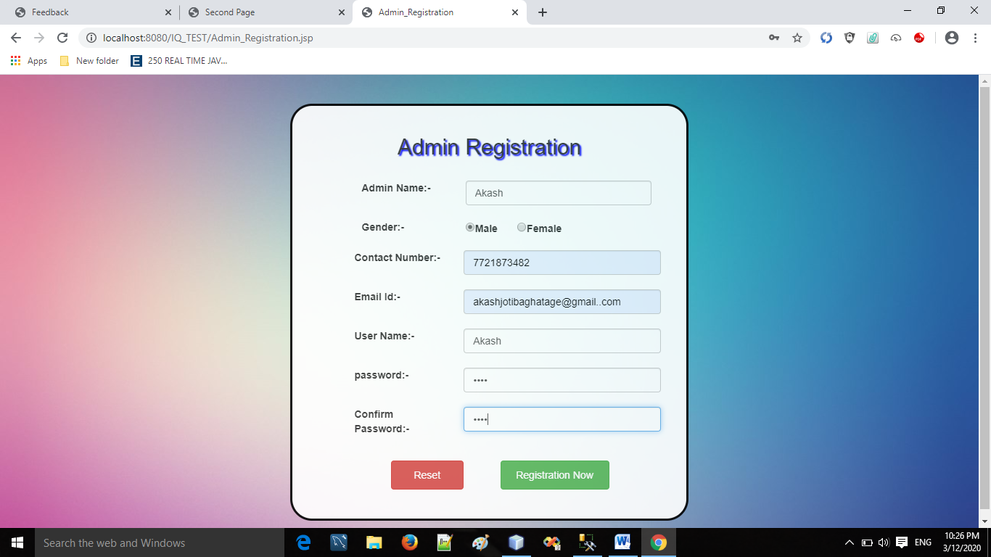

* **Admin Login:**

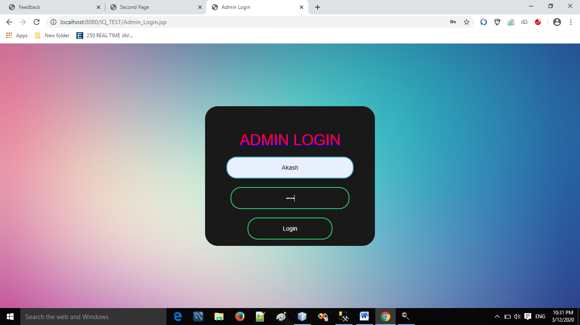

* **HOME PAGE:**



* **Admin Panel:**

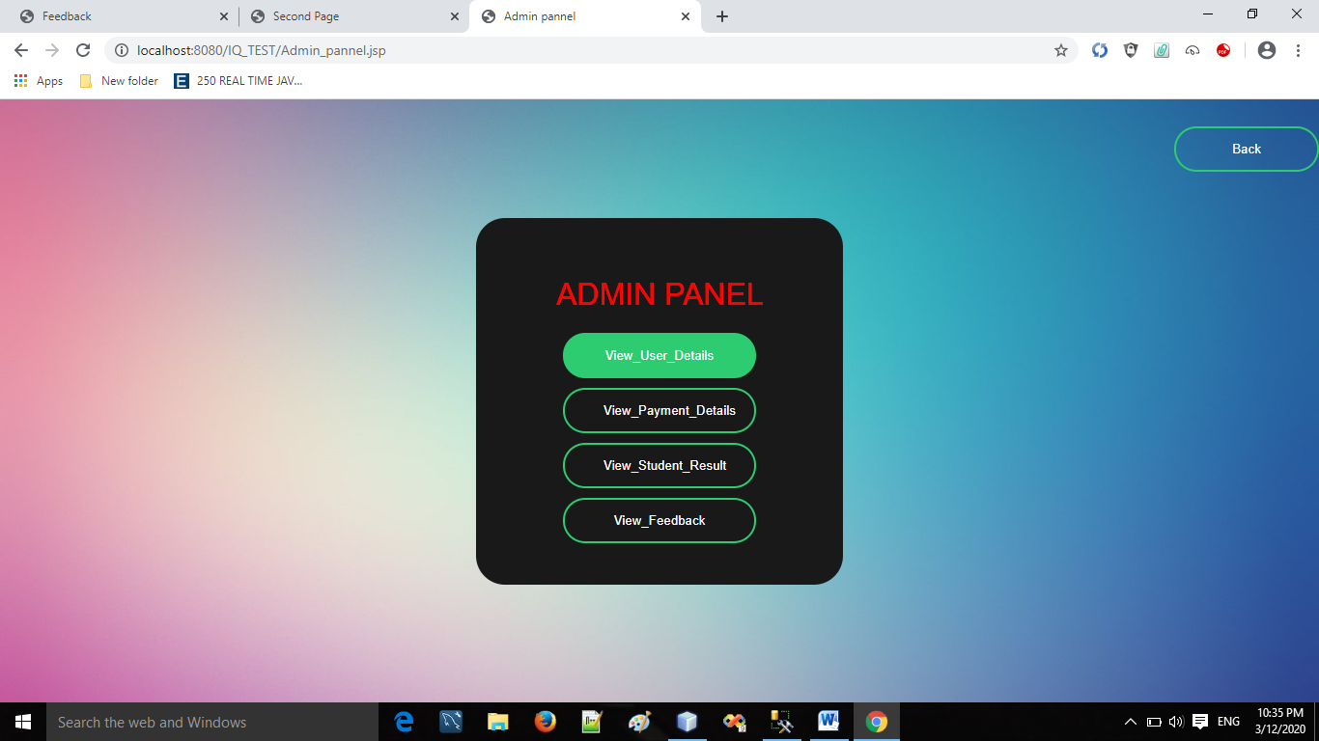

* **Student Details:**

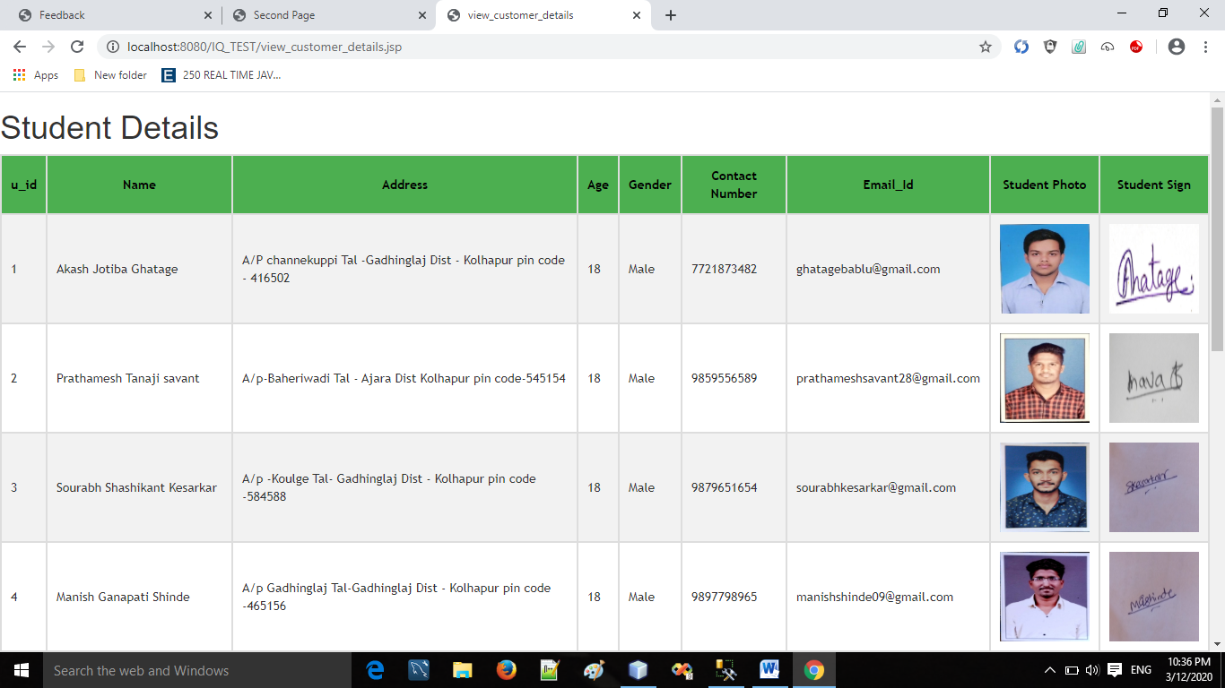

* **Payment Details:**

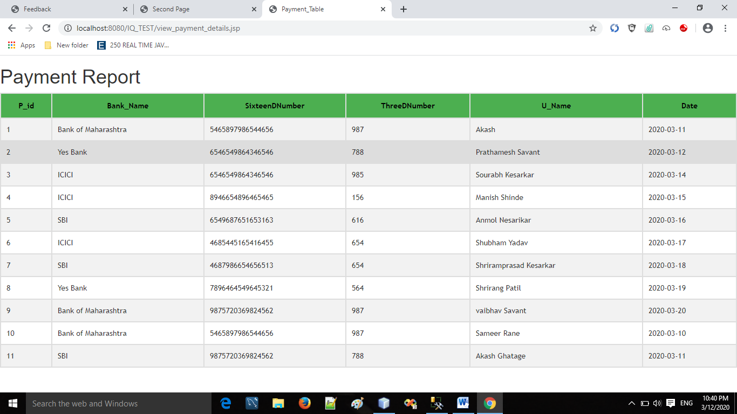

* **Students Result Details :**

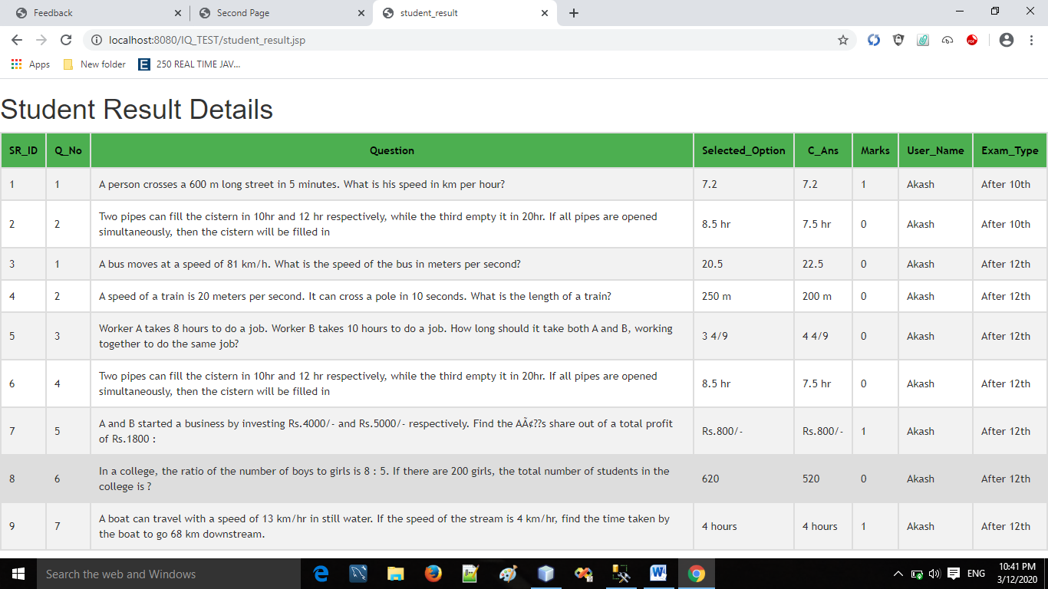

* **Feedback Details:**

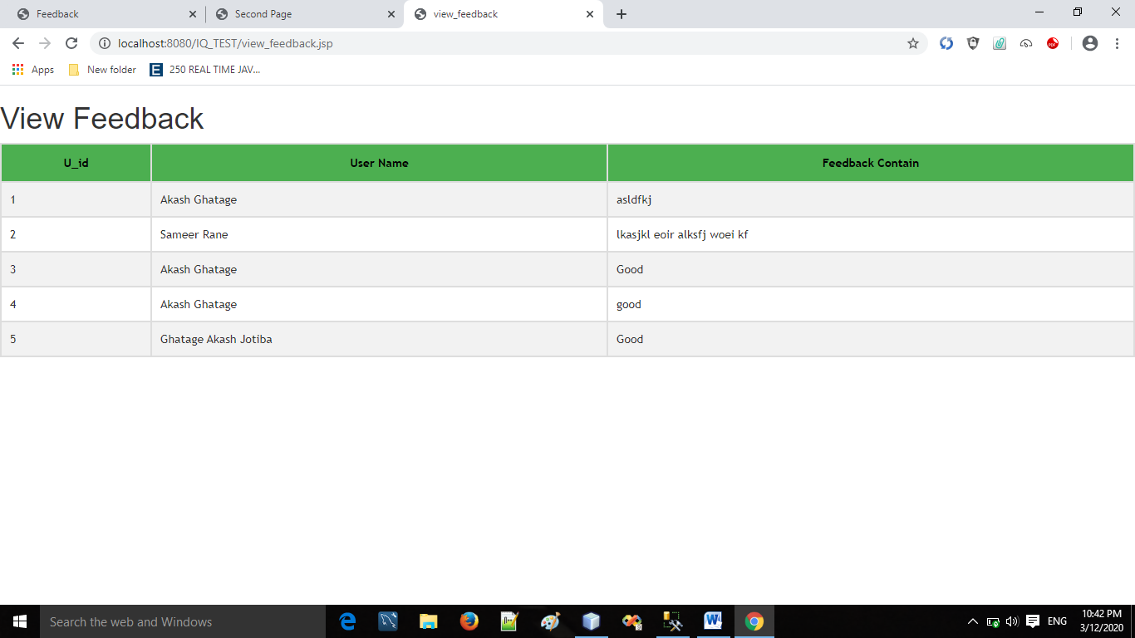

* **Set Exam Time :**

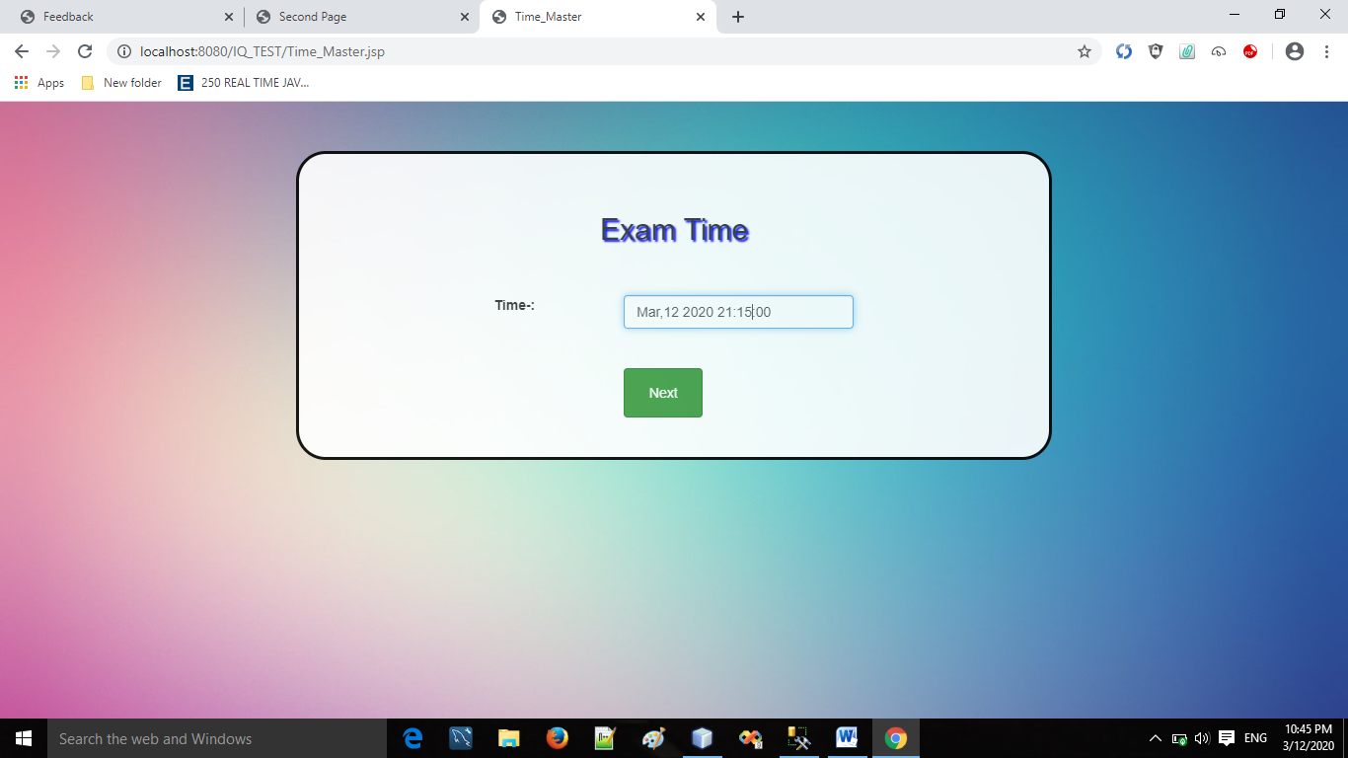

* **Set Exam Type (10th or 12th):**

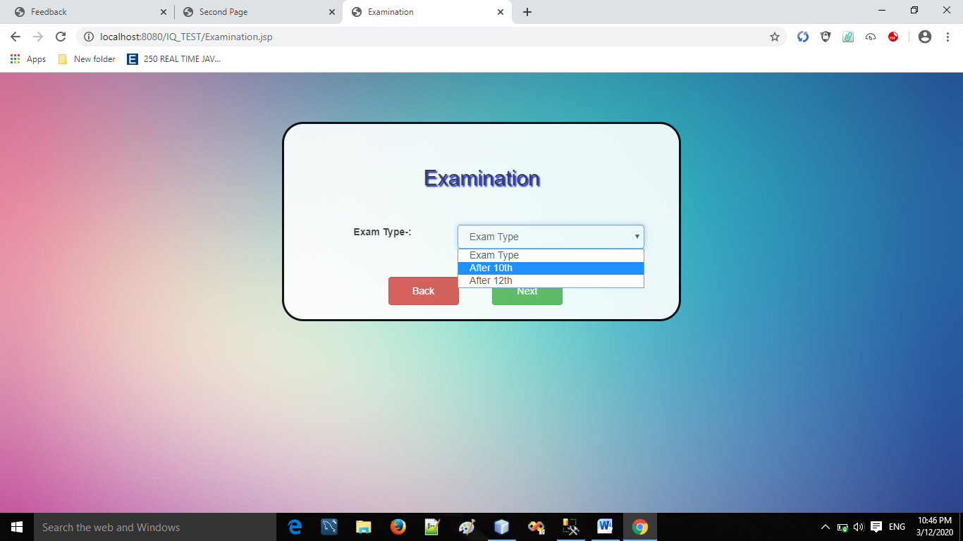

* **Add Questions Page:**

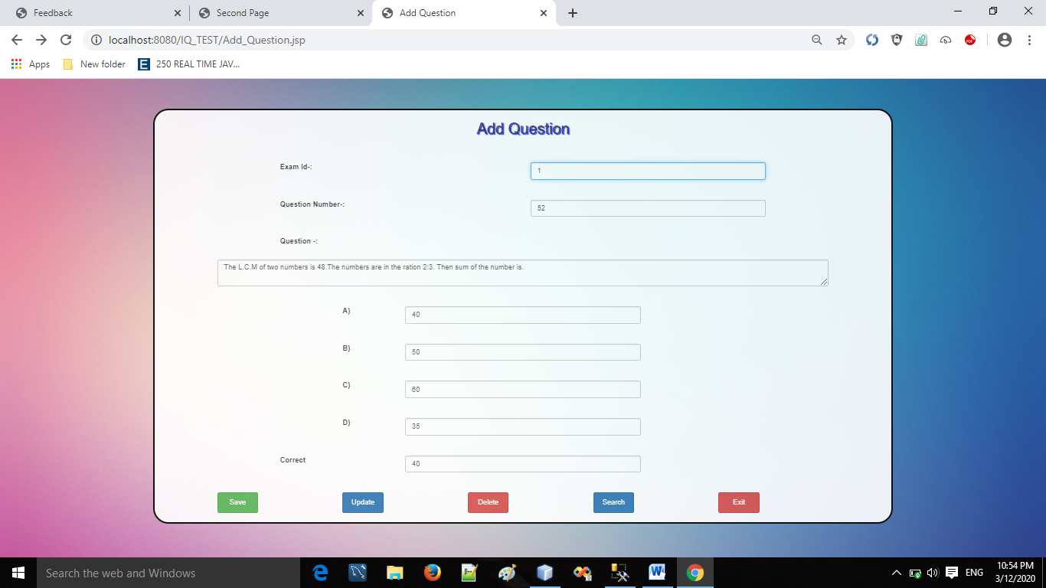

* **User Registration:**

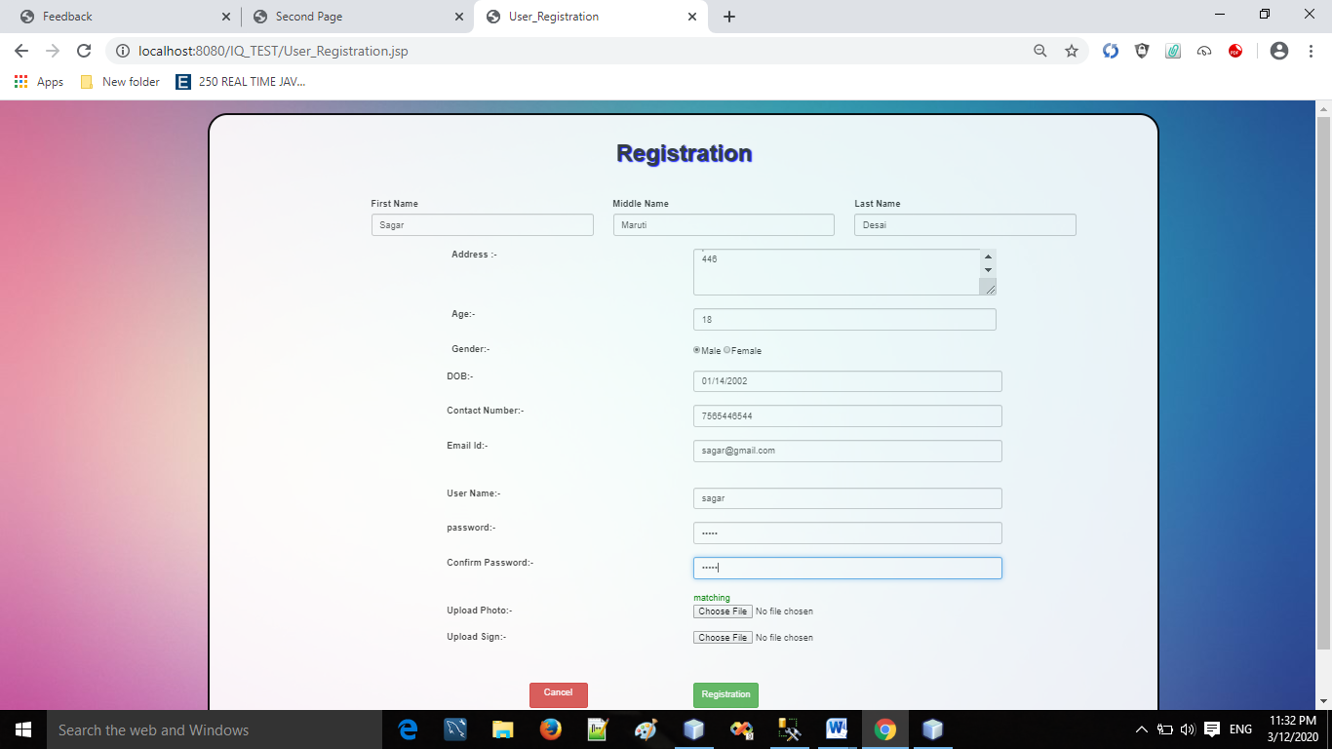

* **User Payment:**

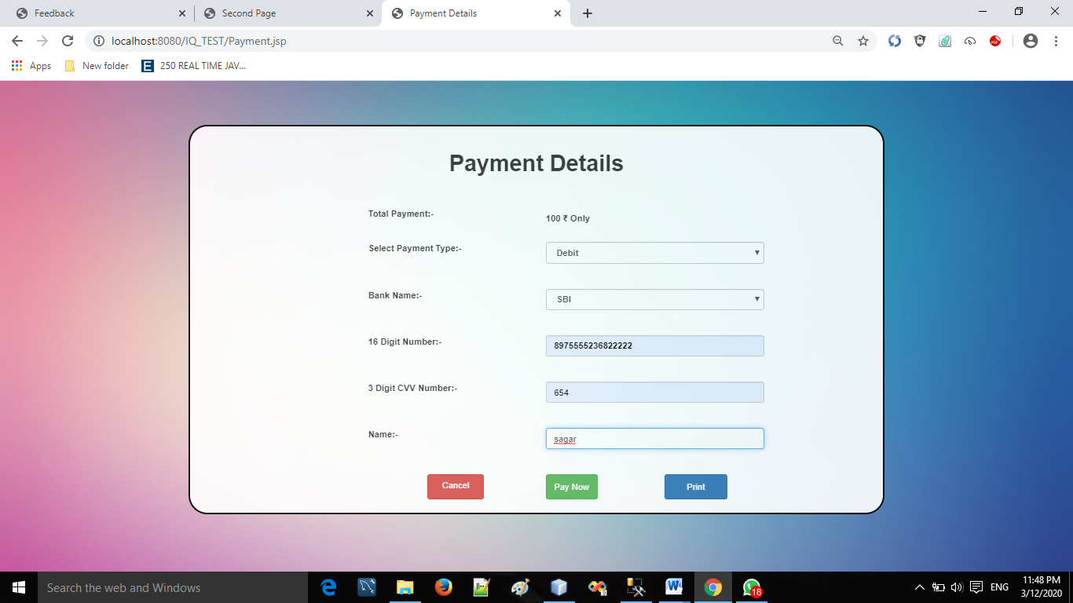

* **User Login:**

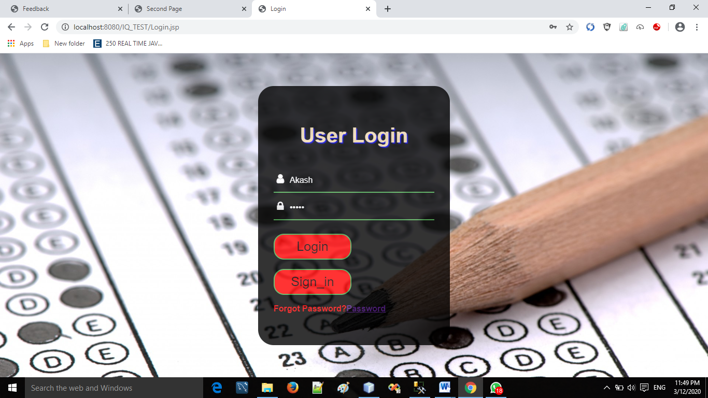

* **User Homepage:**



* **User Profile:**

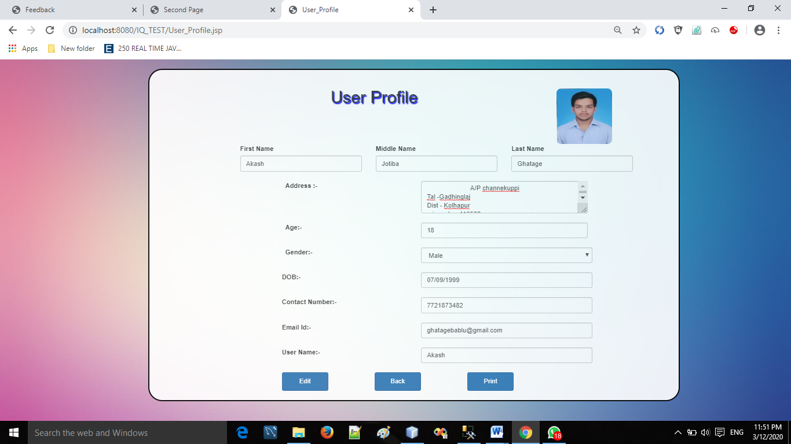

* **User Exam Type:**

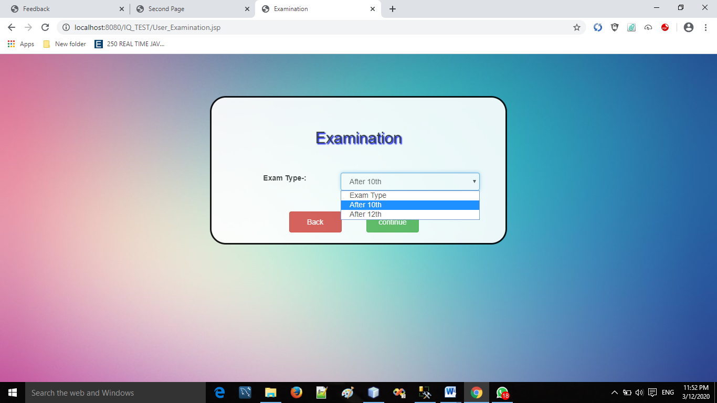

* **Test Instruction:**

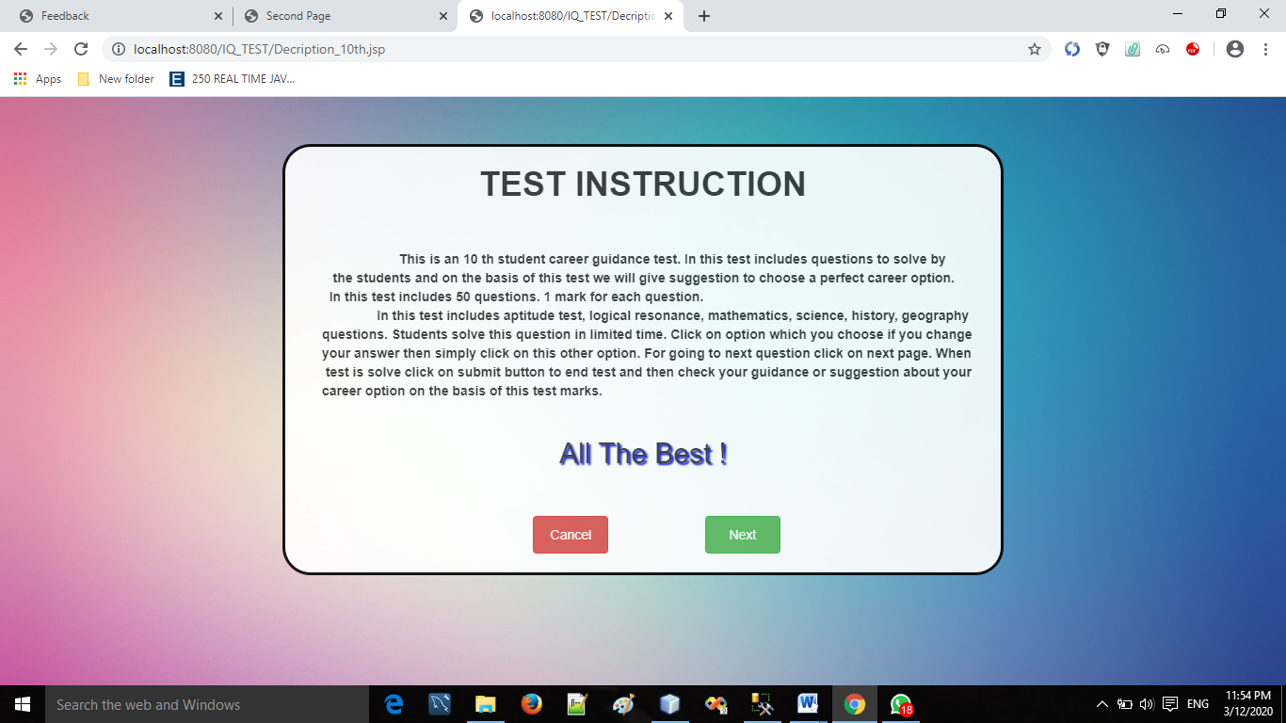

* **Test Page:**

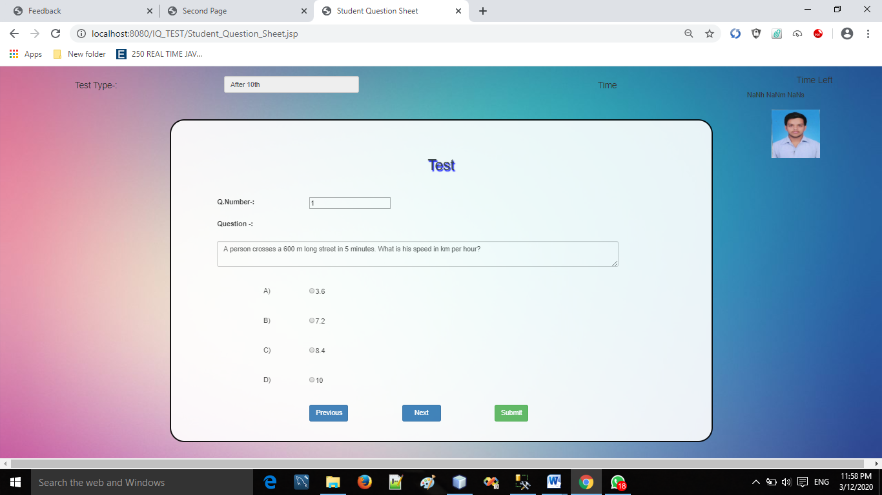

* **Result Page :**

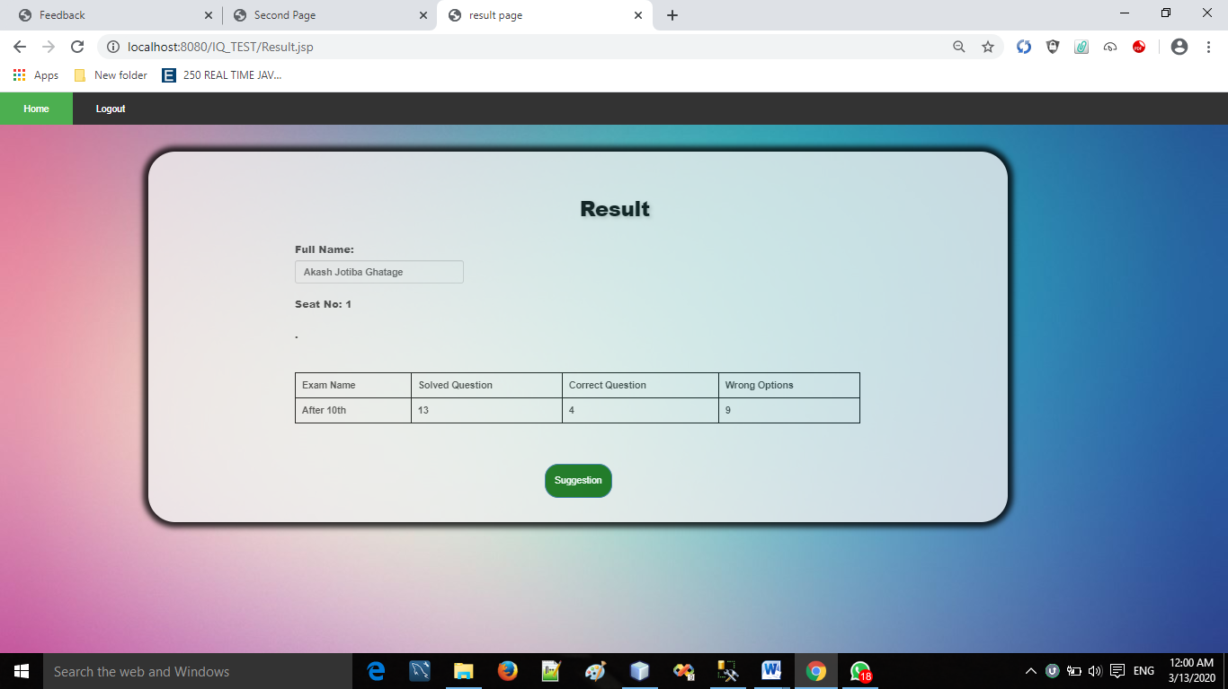

* **Suggestion :**

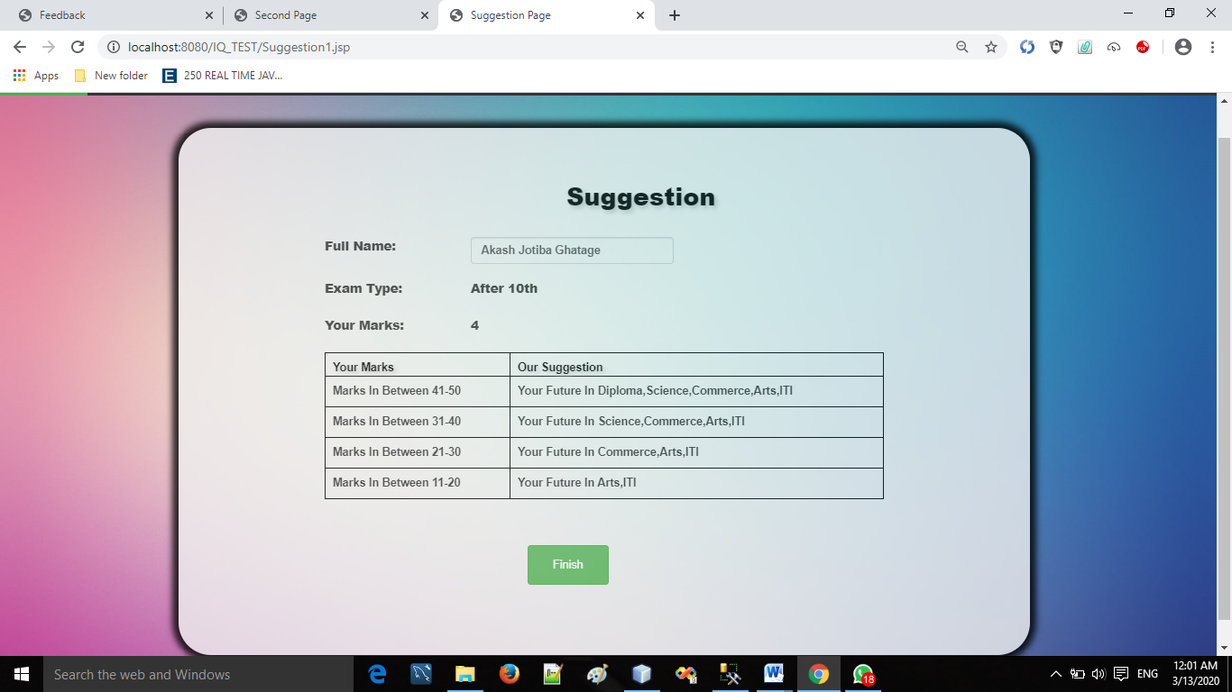

* **Feedback page:**

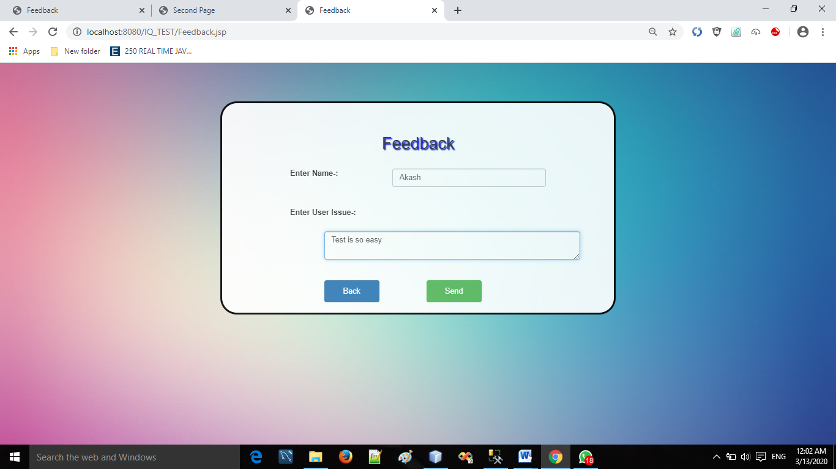

* **About us:**

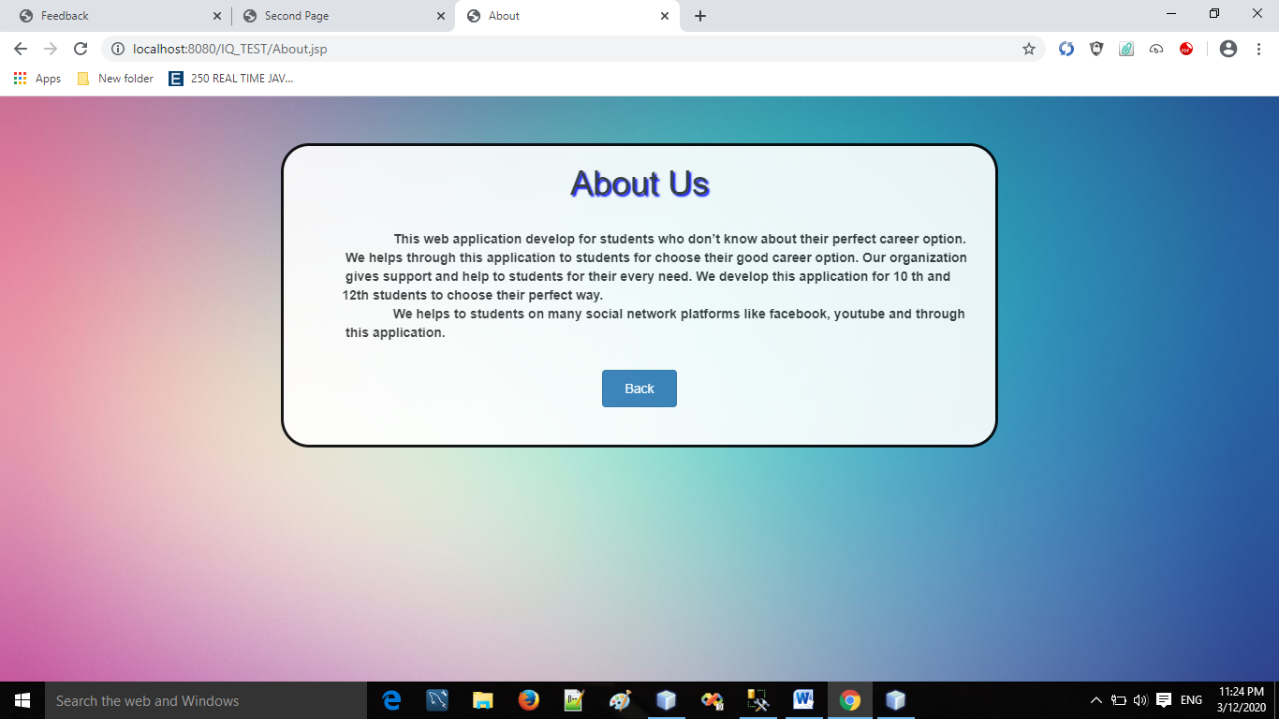

* **Contact us:**

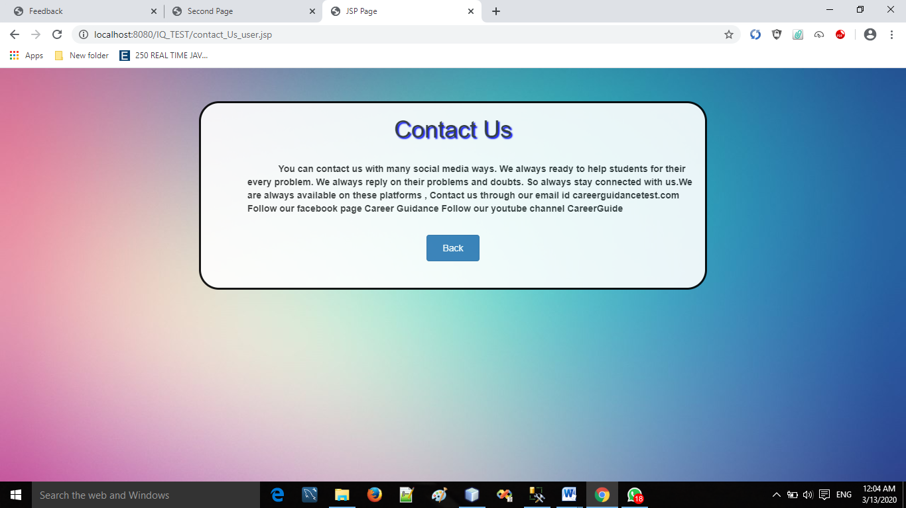

* **Forgot password :**

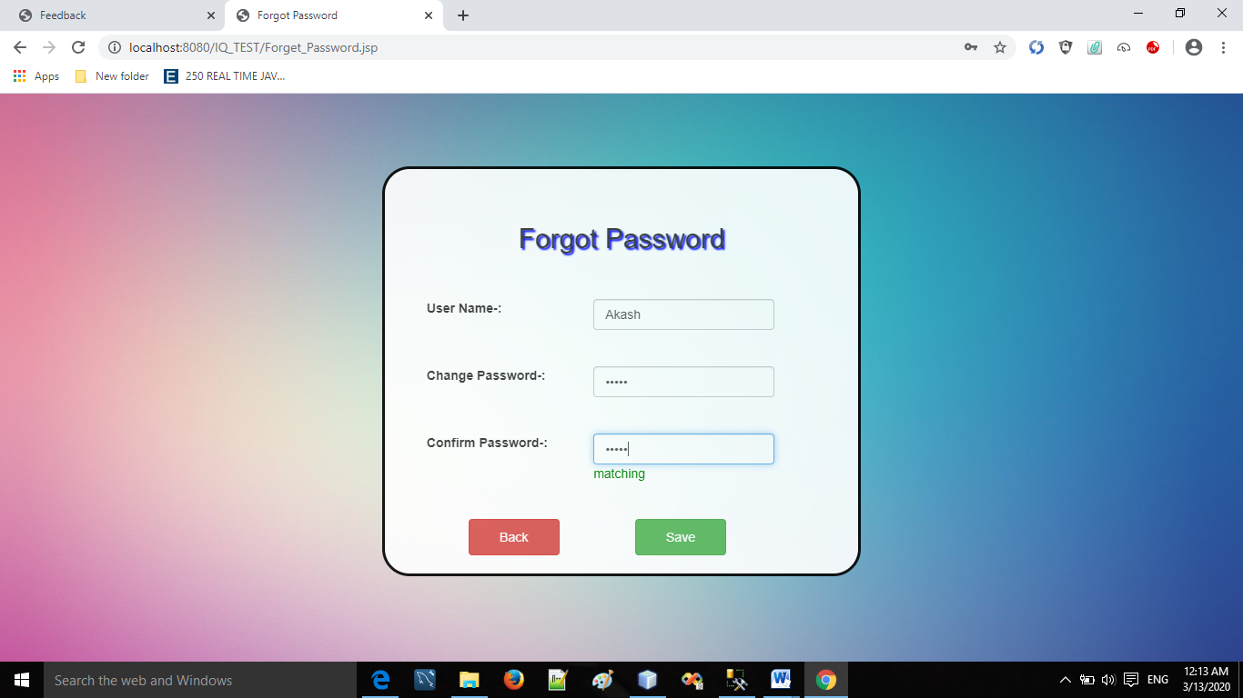

reports

* **Report Page:**

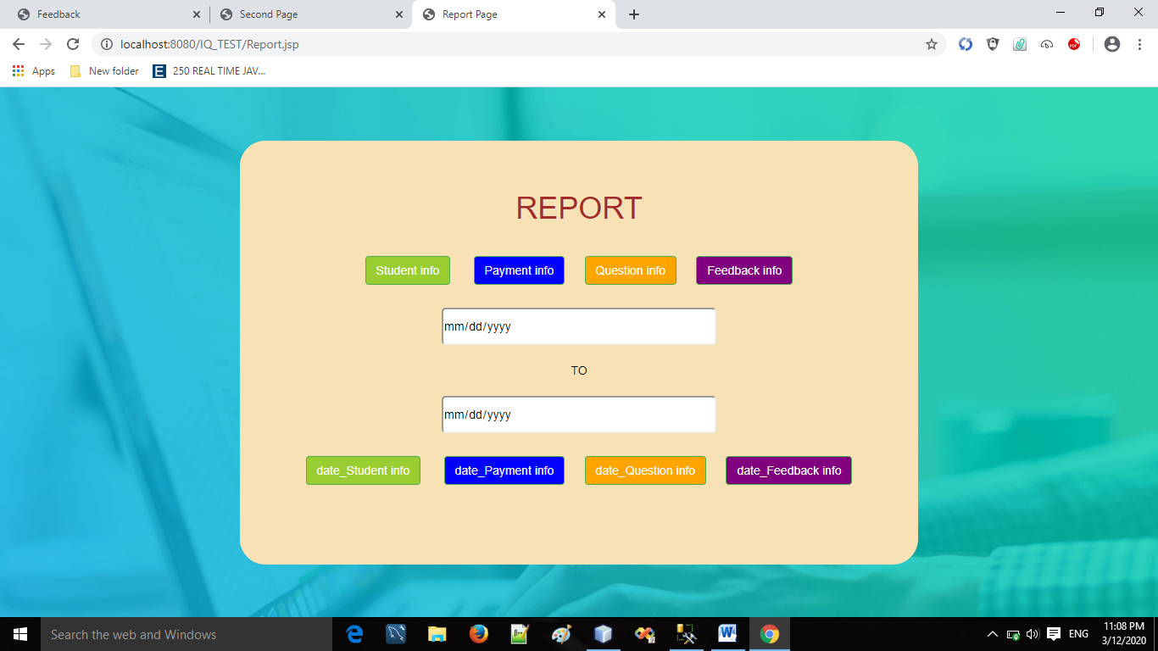

* **All Student Details :**

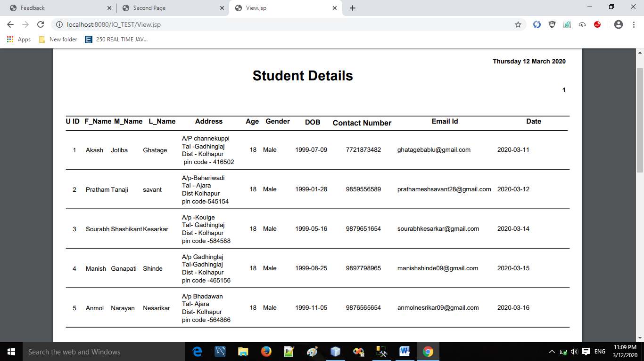

* **Date wise Student Details:**

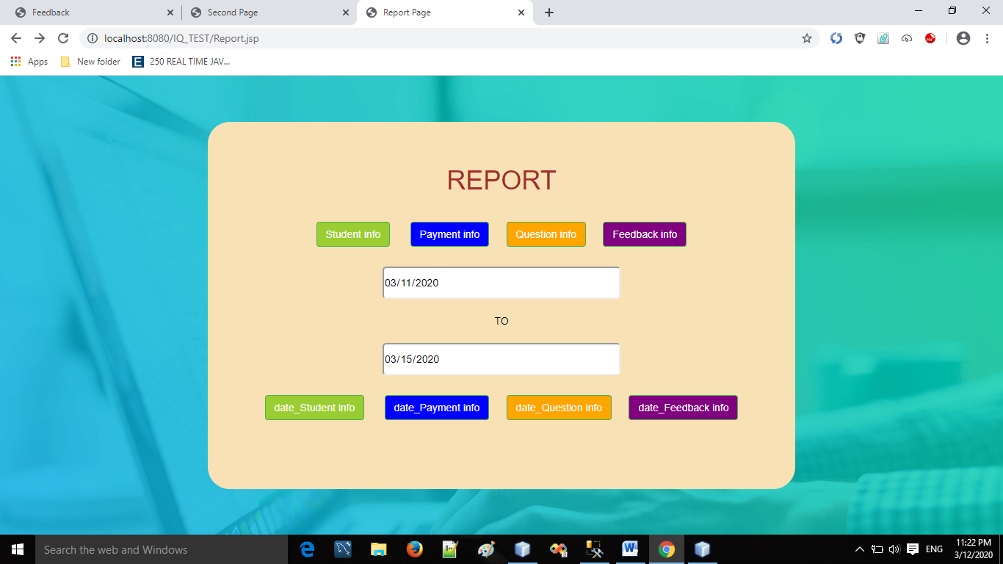

* **Student Details :**

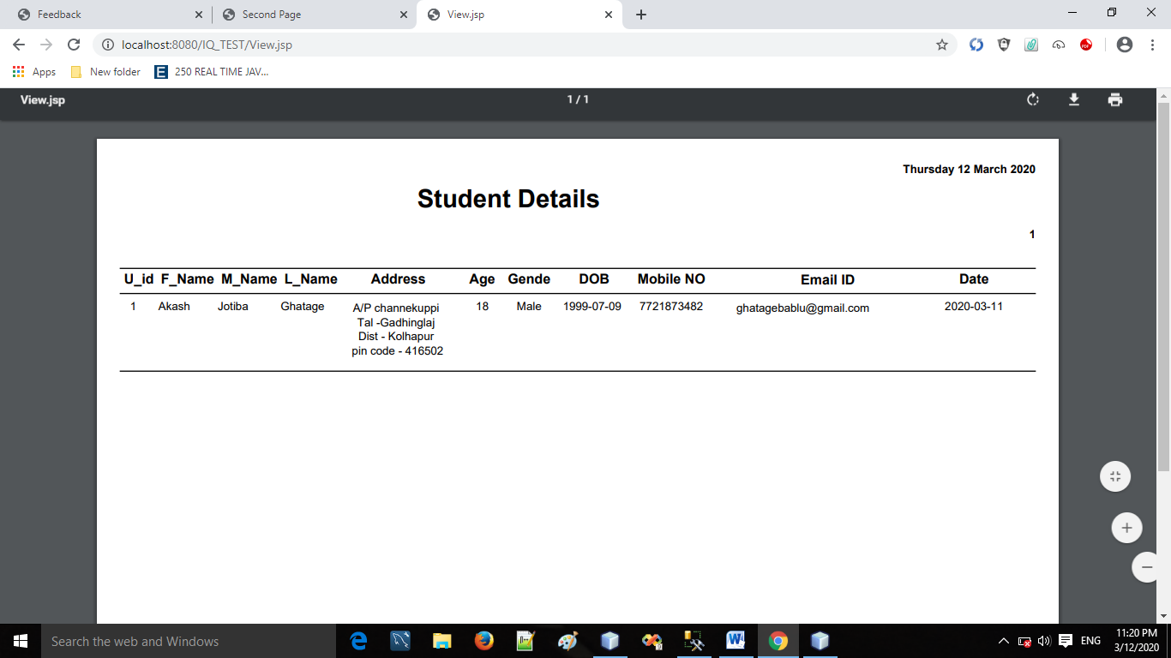

* **All Question Details Report:**

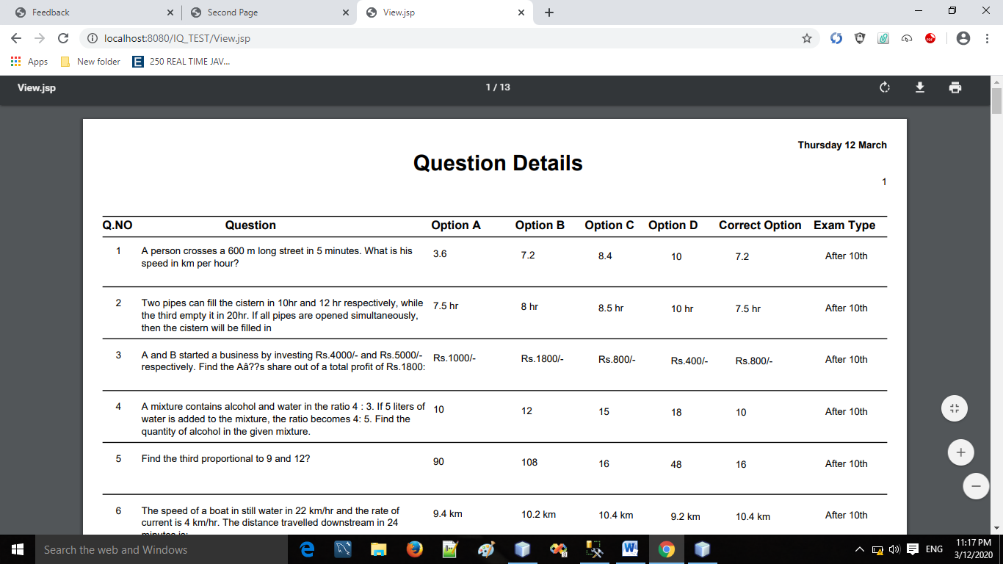

* **Date wise Question Details Report:**



* **Question Detail:**

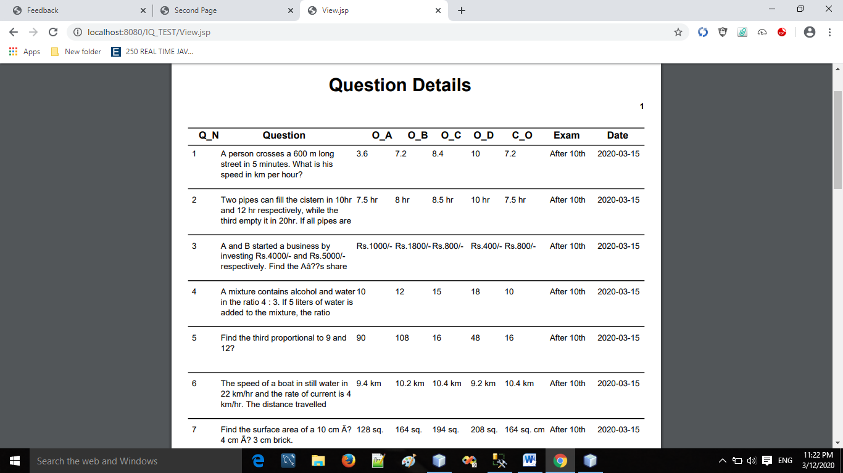

* **All Payment Repots :**

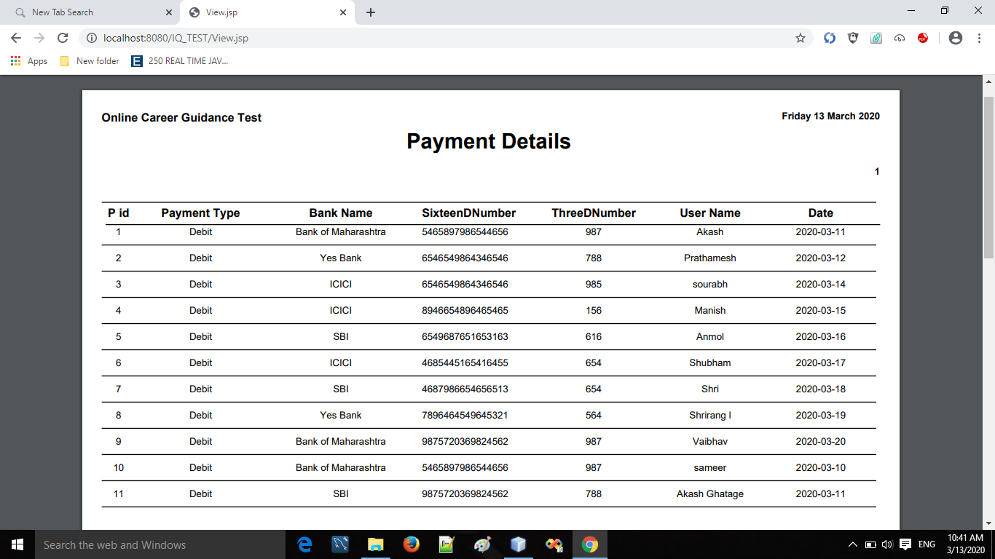

* **Date Wise Payment Report :**

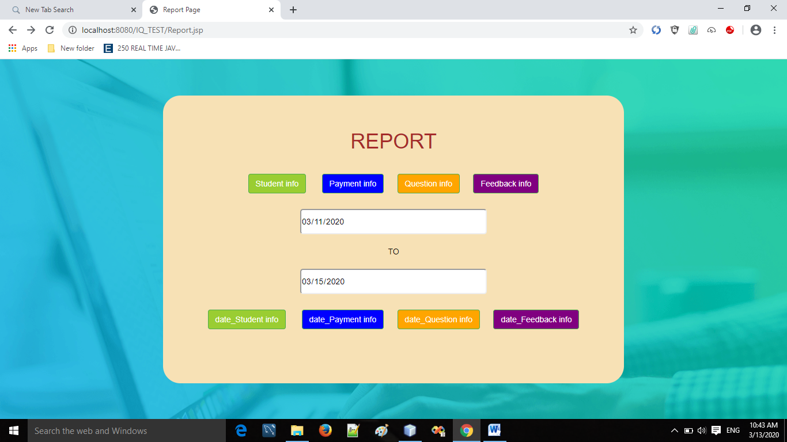

* **Payment Details :**

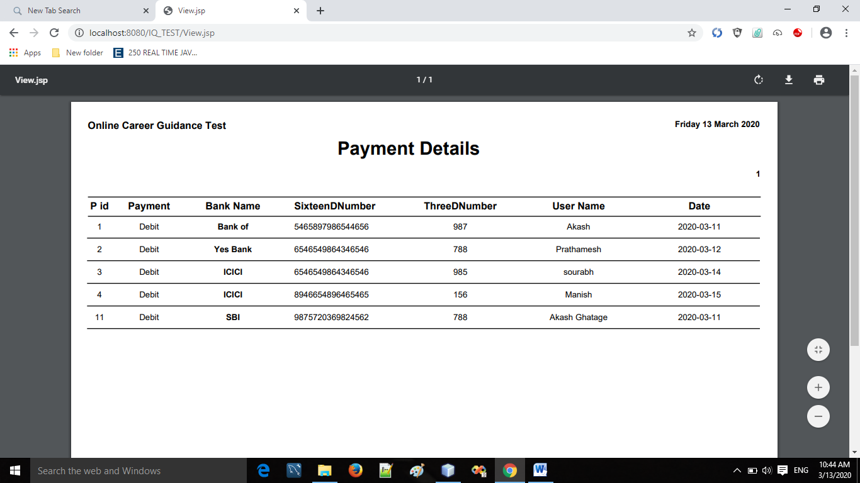

* **All Feedback Report :**

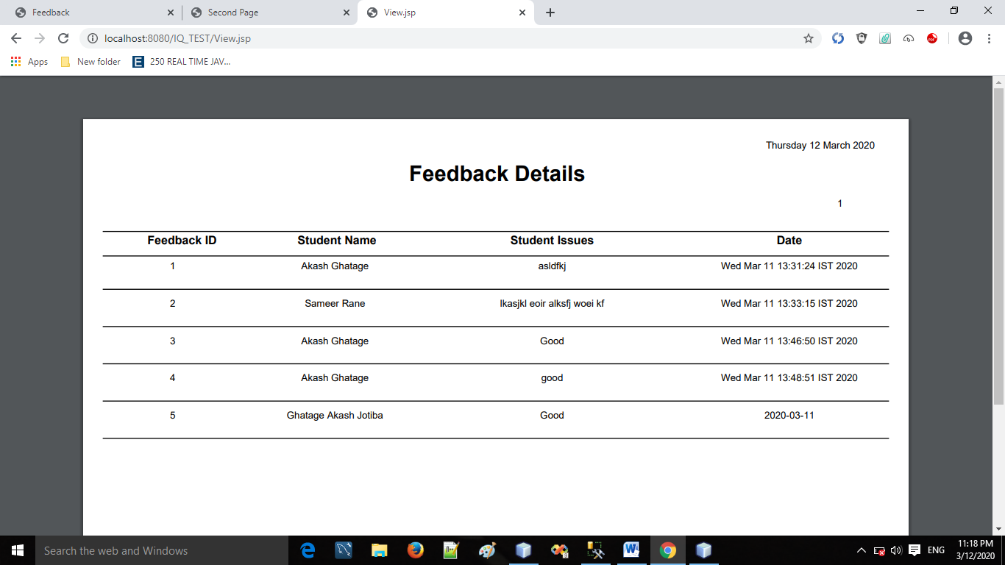

* **Date Wise Feedback Report :**

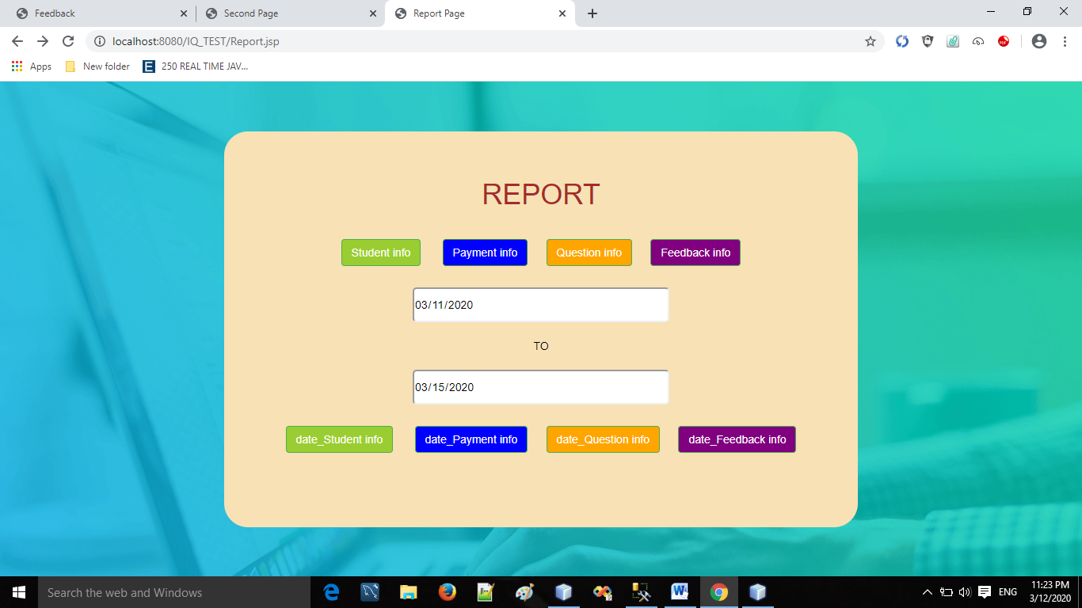

* **Feedback Details :**

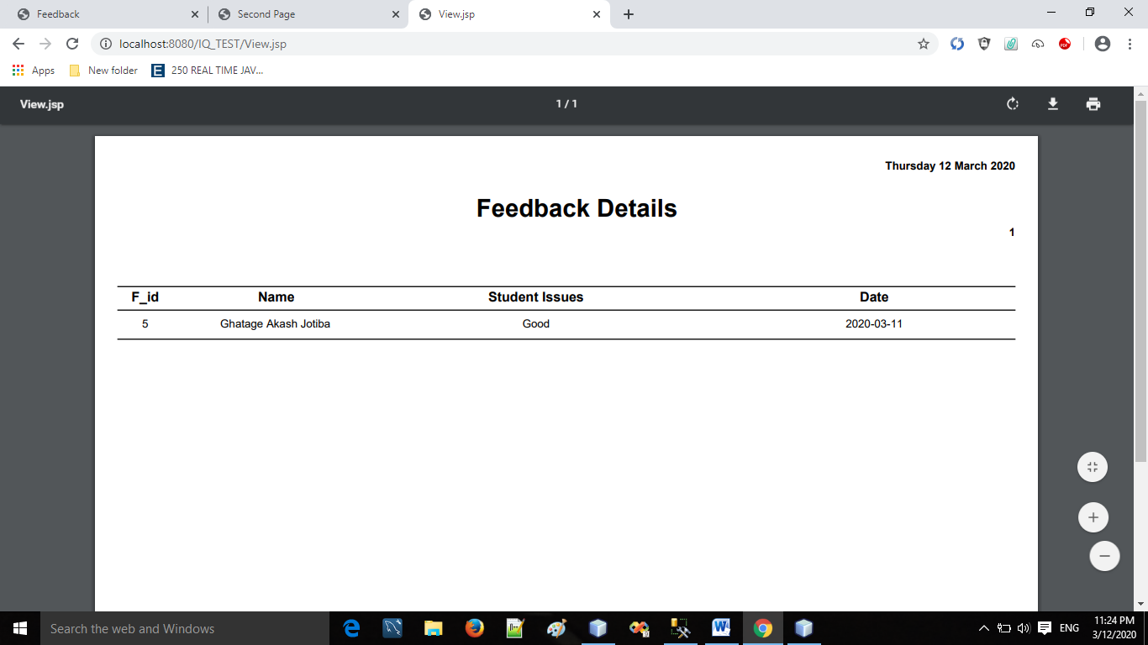

**LIMITATION**

* **Limitation of system :**

1. User should have minimum (basic) knowledge about computer to handle the software
2. System limited for 10th and 12th students only, not for other field.
3. Maintenance cost is expensive.
4. Only a trained user can handle the system.

**CONCLUSION**

After designing and implementation of this system we have come to the following conclusion.

1. Due to computerization we can easily add multiple of test for students and we can easily update, delete and search any test or information.

2. It is easy for students to handle system and use effectively.

3. Due to computerization, a lot of time is saved because all the paper work can be done on computer with greater accuracy.

4. Test process is very easy, due to students give test easily.

5. Print- out of records can be taken.

**SUGGESTION**

To overcome the limitation of the system there are some suggestions-

1. System update module required as per students interest and their use.
2. For better accuracy, correctly inputting data is required.
3. More fields add for different field students.

**BIBLIOGRAPHY**



**JAVA Programming (black book):** Steve Hoizner

**Introduction to java programming:** Danial Liang

**HTML and CSS :** Jon Duckett.

**Software Engineering:** Pankaj Jalote

**System Analysis And Design:** Adward F.H

**Websites:**

www.google.com

www.slideshare.net

www.123test.com

www.wikipedia.com